# SRTSweb

There are several benefits in using SRTSweb in the medical readiness field. Because SRTSweb is a web-based application it eliminates the need for client application software, satisfies the Tri-Service Information Assurance (IA) requirements, and provides the user with a state-of-the-art tool to accomplish the mission. Users can go to any computer and log in to SRTSweb.

Additionally, there is no application specific hardware to maintain, no software to install, and no application software updates. There will be little or no impact to the user during server upgrades, maintenance, or back-ups. The user will type in an address in the URL field of an Internet browser, or save it to their Favorites drop-down menu in their Internet browser for easy access. SRTSweb ends the need for the application to be hosted and managed at each clinic location. This action is accomplished by centralized servers that provide for less local site management in support of the application, resulting in reduced support requirements on the end users.

# LOGGING INTO SRTSweb

<https://srtsweb.amedd.army.mil/>

Type in the SRTSweb URL to access the application. The first screen displayed in the application is the SRTSweb User Agreement screen. Read and accept the SRTSweb User Agreement to proceed.

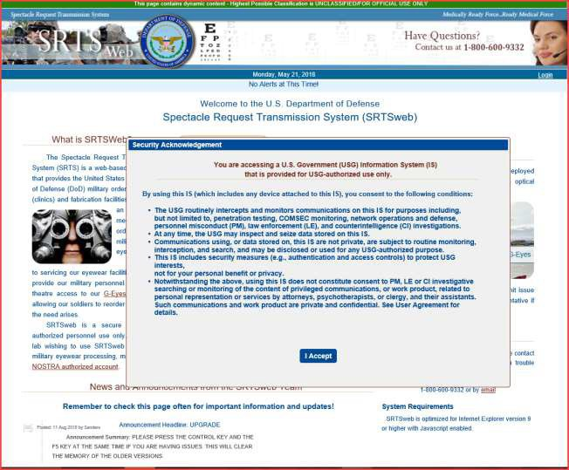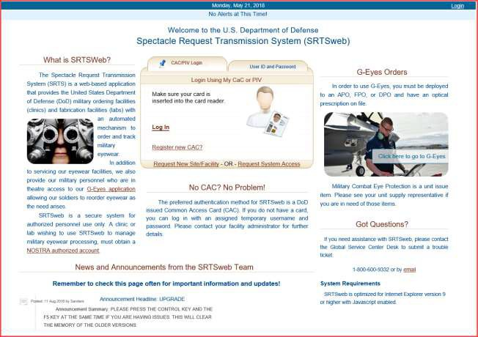

The screen will display the **G-Eyes** Orders link for deployed patients. The patient must have orders on file to reorder glasses.

The screen has a **Check Order Status** for patients to track their orders. The patient does not have to log into SRTSweb.

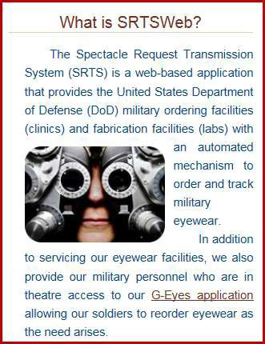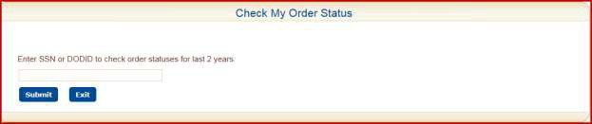

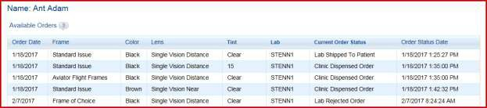

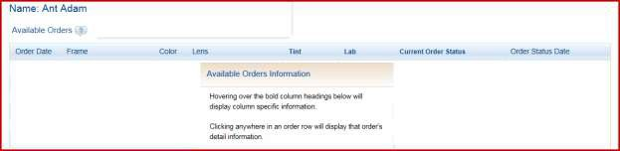

The screen also has a short cut for NOSTRA Web Site.

The screen will display the welcome and log in screen of SRTSweb.

If the clinic admin added the user with their DOD, the user can log in with their CAC.

If the clinic admin added the user without their DOD the clinic admin will provide the user with a login. The password will be emailed to the new user from SRTSweb.

Select the option to login: CAC/PIV Login or User ID and Password.

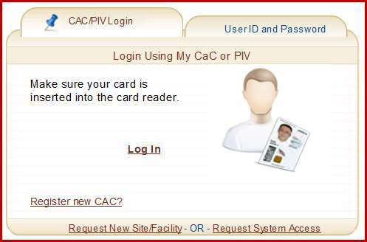

### NOTE: User must log in every 60 days or account will be locked. The admin user can unlock the tech. SRTSweb is the only one to unlock the admin.

Select the DOD Email Certificate to log as a Clinic Tech, Clinic Clerk or Provider.

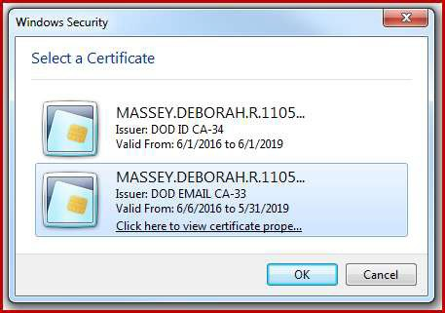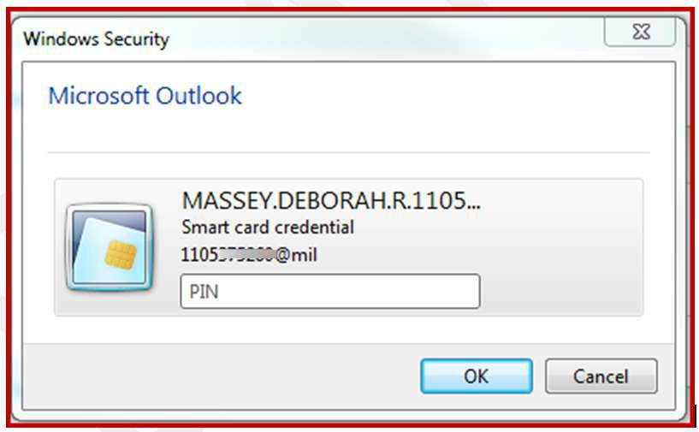

Press OK

Press OK.

The user cannot log in with an ID and Password after the CAC is registered. A message will appear to alert the user to use their CAC.

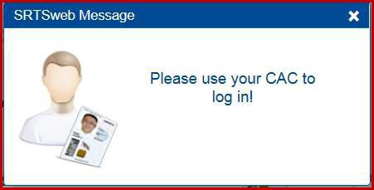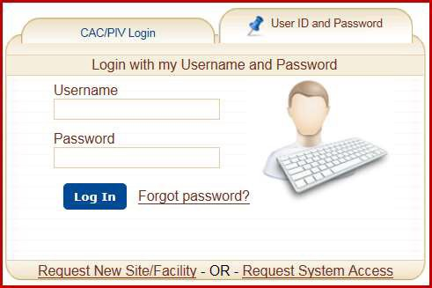

Username and Password.

Type in

The user will be locked out if password is typed wrong 3 times. Only the admin can unlock the user. Press **Forgot Password** before getting locked out. SRTSweb will email a new password to the email on file for user.

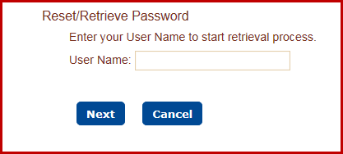

The user must change at least eight (8) characters in the password. The system prohibits the reuse of the last five (5) passwords.

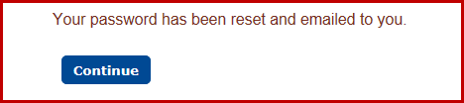

The password has a minimum lifetime of twenty four (24) hours.

Support for customers of the SRTSweb system will come directly from SRTSweb team members located at DHA Clinical Solutions – Army South. The request for support should be submitted via the Global Service Center Desk located at DHA.

For assistance with SRTSweb, please contact the Global Service Center Desk by phone at 1-800-600-9332 or by email at: [dhagsc@mail.mil](mailto:dhagsc@mail.mil) to create a support ticket.

This link is located on the log in page.

After selecting the proper CAC certificate to access the application the user must acknowledge the Rules of Behavior / Acceptable Use Policy screen. To continue using the system, the users will only have to click this acknowledgment once annually.

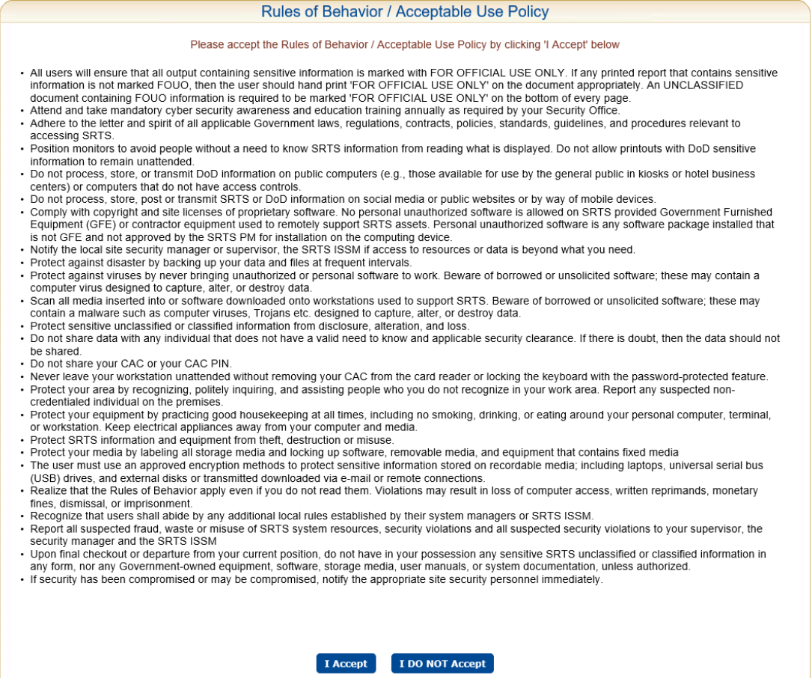

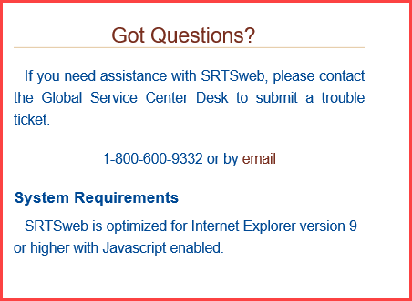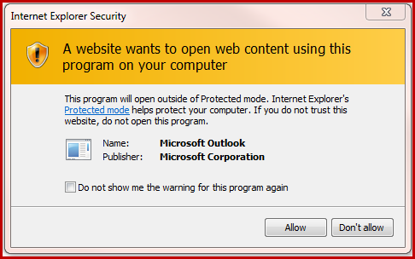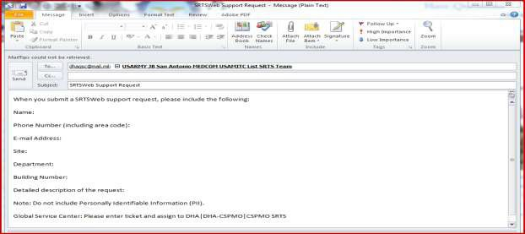

Clinic clerk or tech users have a session time out of 15 minutes.

Users will see a 5 minute Logout Warning at the 10 minute warning. Pressing anywhere on the screen will continue the session for the user.

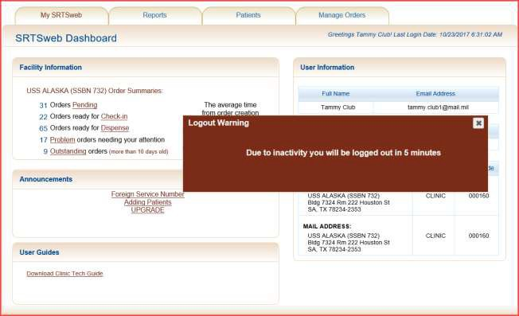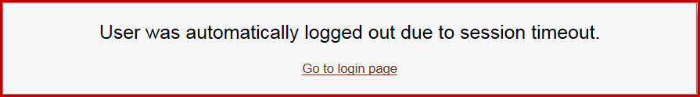

Users will automatically be logged out if the screen is not touched either at the 5 minute warning or within 15 minutes.

Users will have the following message if the Logout is pressed to exit the application.

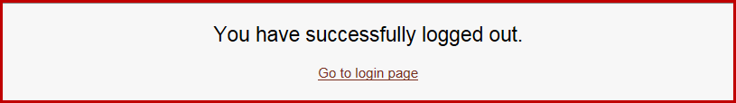

# SRTSweb Dashboard

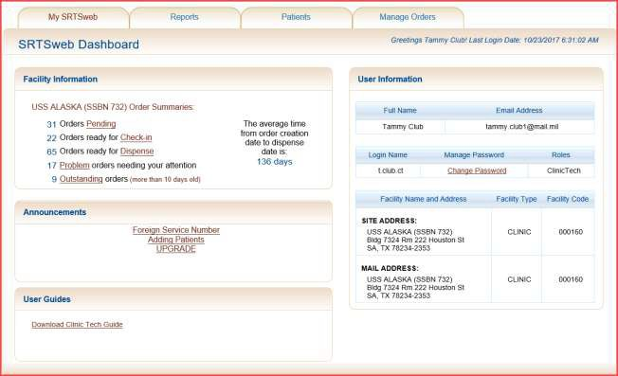

Once logged into the system as a user with Clinic Tech privileges, the screen contains a title bar, and a menu of tabs: My SRTSweb, Reports, Patients, and Manage Orders.

On the right side of the title bar is a link to logout of the SRTSweb application.

The dashboard shows the current Username. The dashboard also shows the user with the last successful login date and time prior to the current log on session on the right.

Directly below the tabs, the SRTSweb Dashboard is displayed. The Dashboard can also be accessed by selecting the My SRTSweb tab from anywhere in the application. The Dashboard can also be accessed by pressing the SRTSweb logo.



The Dashboard is composed of 4 sections: Facility Information, Announcements, User Guide on the left and User Information on the right.

Announcements and Guides are under Facility Information.

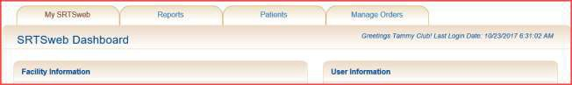

**Facility Information Clinic Orders Summary**

On the left side of the Dashboard, a section called Facility Information.

The Clinic Order Summary shows totals of the site’s orders by status to include:

* Orders Pending
* Ready for Check-In
* Ready to Dispense
* Problem Orders
* Outstanding Orders

Each status provides a shortcut to the same application sections under Manage Orders. Also, this section shows the average dispense time from order creation date to dispense date for the site changing on a 14 day cycle.

## Announcements

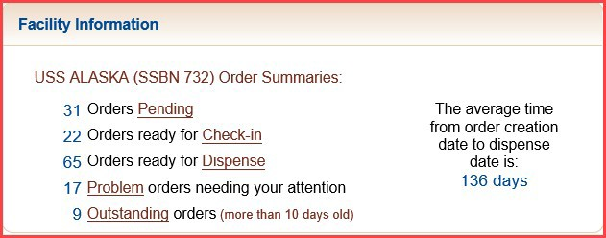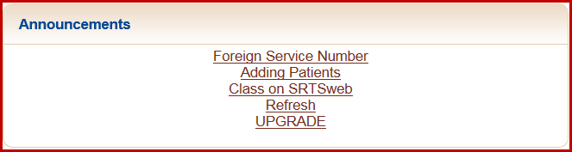

Announcements can be viewed from this screen. The same message can be viewed under My SRTSweb - My Message Center. Announcements come from your admin or the SRTSweb team.

## User Guides

For users logging in with the Tech, Clerk or Provider role User Guide for the Clinic Tech can be downloaded from this screen. The guide is written using the tech role.

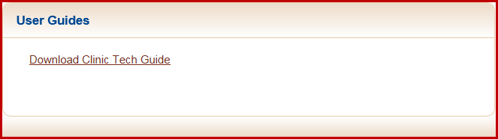



**User Information**

On the right side of the Dashboard is the My Profile Information section which displays user profile information. Included in the login information is the user’s Full Name, Email Address, Login Name, a link to Manage Password and the user’s assigned Role(s).

This section also contains the Facility Name and Address, Facility Type, Facility Code and facility’s mailing address.

Only a user with administrator privileges can update the clinic user information.

A user may change his SRTSweb login password by clicking on the **Change Password**

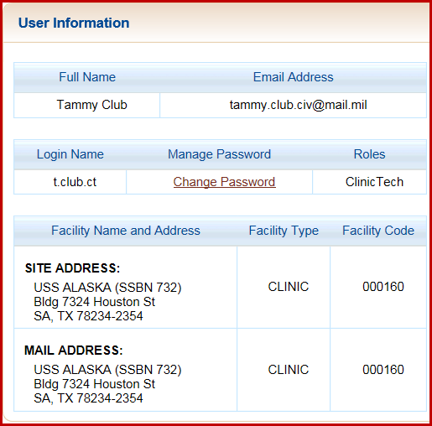

link.

Once the CAC is registered the login and password are no longer needed.

The user must change at least eight (8) characters in the password. The system prohibits the reuse of the last five (5) passwords.

The password has a minimum lifetime of twenty four (24) hours.

The password can only be changed after 24 hours of previous change.

User passwords expire every 90 days. Passwords requirements are:

* Minimum of 15 characters long
* 2 upper case characters
* 2 lower case characters
* 2 numbers
* 2 special characters! @ # $ % ^ & * ( )

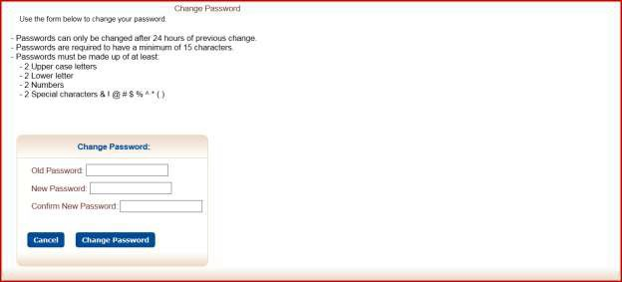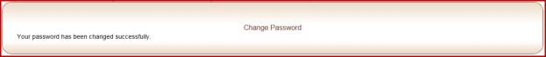

After changing the password a confirmation message is displayed.

Press My SRTSweb to go back to dashboard.

User can also press on the SRTSweb logo at the top on the left from anywhere in the app to return to dashboard.

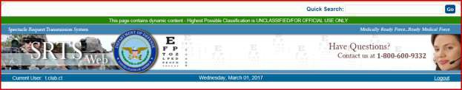

A "**Quick Search**" feature has been implemented to allow searching orders, searching patients and adding patients from anywhere within SRTSweb. The field and button are anchored to the top of the page. The user may enter an order number (including the dash), a SSN with no dashes, or a DOD ID number into the field and click Go.

The system will interpret the input data and take the user to the correct screen.

"**Quick Search**" is discussed more in the **Add Patient, Order Check-In and Order Dispense**.

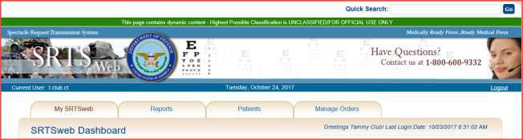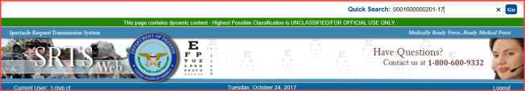

# My SRTSweb

If the mouse pointer hovers above the My SRTSweb tab, a drop down menu appears for two process modules: My Message Center and Release Notes.

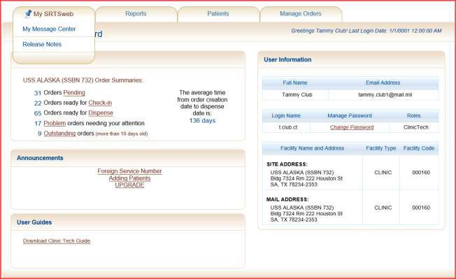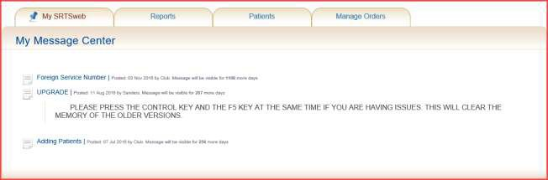

## My Message Center

Messages and Announcements can be viewed by clicking My Message Center on the My SRTSweb drop down menu.

Users can also click on the message in the SRTSweb Announcements box on the Dashboard screen to read messages and announcements.

These messages can be from the clinic admin and/or SRTSweb.

## Release Notes

To view release notes for the current SRTSweb version, select Release Notes from the My SRTSweb drop down menu. Users can also click on the version number at the bottom of the Dashboard screen to see release notes.

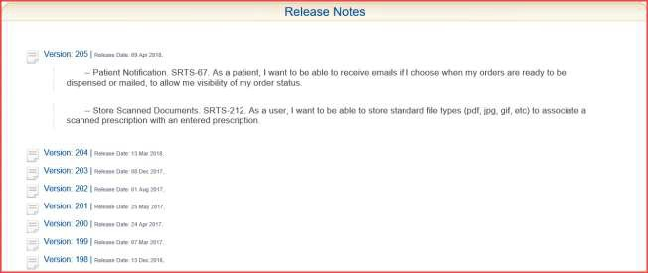

Release Notes are updated at every update or fix in the system.

To go back to dashboard press either the back arrow or the link SRTSweb Home at bottom of page.

User can also press on the SRTSweb logo at the top on the left from anywhere in the app to return to dashboard.

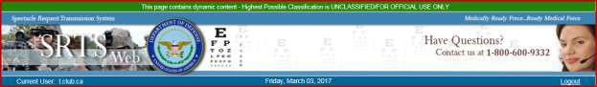

## Reports

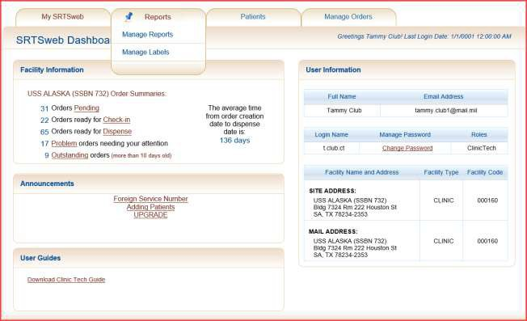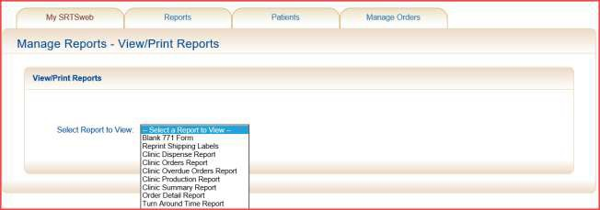

**Manage Reports**

Depending on which role the clinic user is assigned, a set of reports will be displayed as a drop down list in the Select a Report to View field.

To view a report select the From Date and the To Date by selecting a date from the calendar or by entering a date range. Dates entered manually must in be the format: *mm/dd/yyyy*. Optional fields for the report specification are Status and Priority. If all status values and/or Priority values are to be included on the report, the Null check box must be checked. Otherwise, enter a Status value and a Priority value to include on the report.

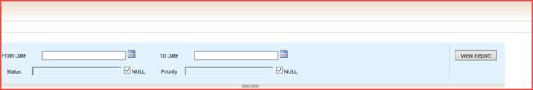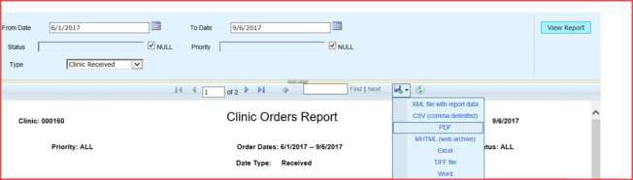

Once the selected report is displayed it can be saved in these formats:

* XML file
* CSV file (comma delimited)
* PDF
* MHTML (web archive)
* Microsoft Excel file
* TIFF file
* Microsoft Word file

To save or print the report, move the mouse pointer above the Export drop down menu and select the file type desired from the drop down list. The user is asked to choose between opening the report and saving it. If opening the report, the Adobe program (Adobe Reader, Adobe Acrobat, or Adobe PDF Converter) can be used to display the report. If the report is to be saved it will be downloaded to the user’s PC.

The user can open, save or cancel the report. Print reports from here.

### NOTE: Mailing label can be reprinted under Reports – Manage Report – Reprint Shipping Labels. The reprint option is good for 7 days.

**This option print all the labels from selected list.**

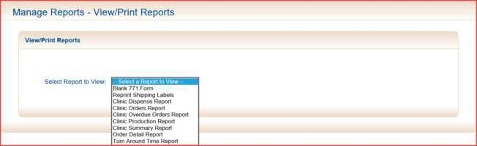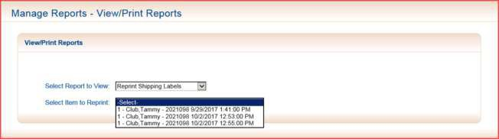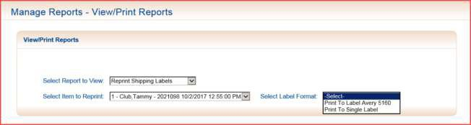

**Manage Labels**

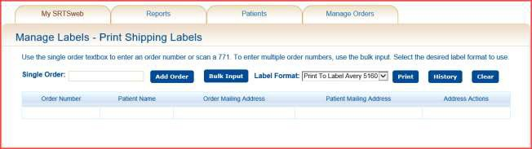

Manage labels gives the user the ability to add order numbers that have not been received, have been dispensed, that were not a MTP (mail to patient) order or were previously printed and are in the History list.

The user has the ability to reprint shipping labels that were designated as Mail To Patient on the order and received. Select History and history item. Press Print.

### NOTE: History labels cannot be update. User must type in order number and press Add Order.

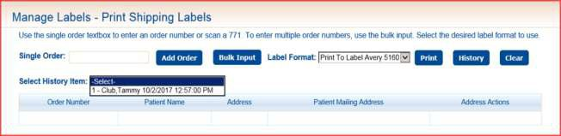

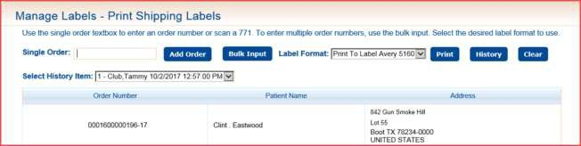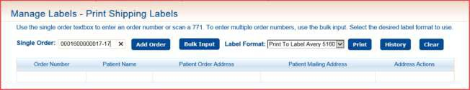

The user has the ability to add orders that were not marked as Mail to Patient by typing, scanning in a single order number and pressing **Add Order** or **Bulk Input**.

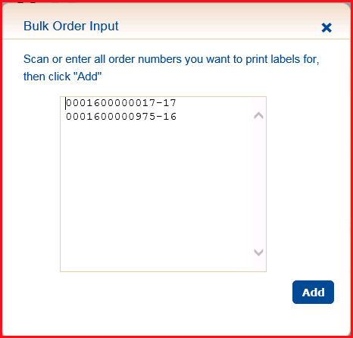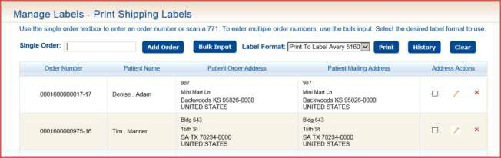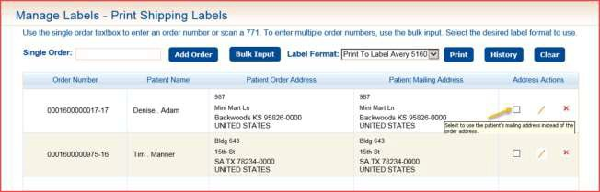

The user has the ability to select patient order address or mailing address. The ability to Update or Delete record.

Select to use Patient’s Mailing address instead of order address.

Edit patient’s mailing address.

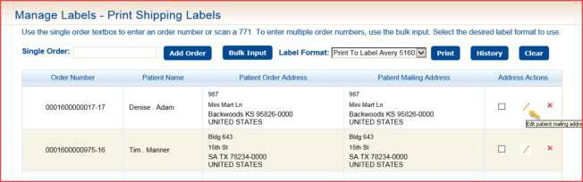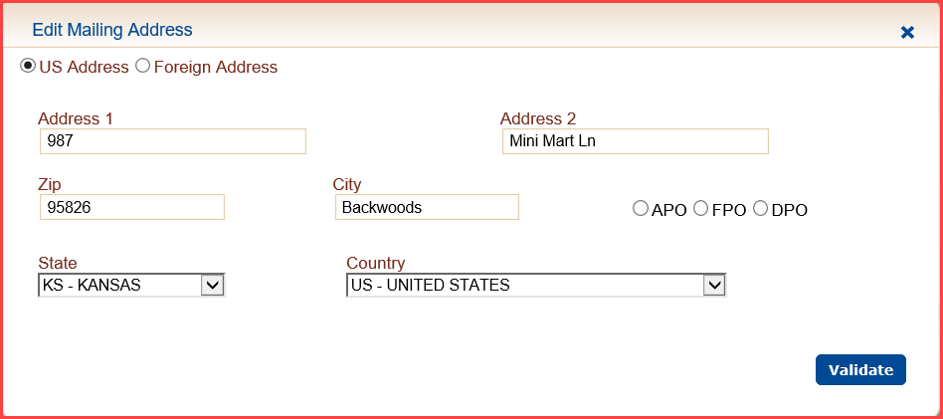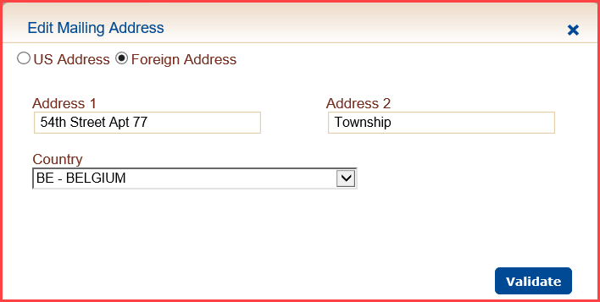

### NOTE: After editing patient’s mailing address, the address has to be validated again before it will be saved.

Remove Order Address from grid.

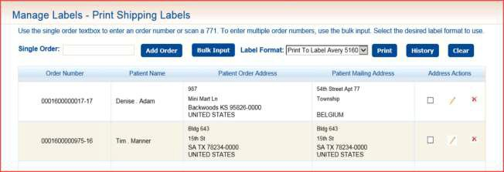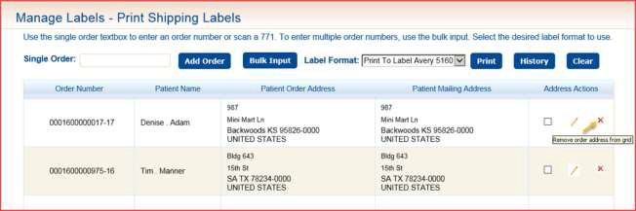

# Patients

Options displayed in the drop down menu under the Patients tab are based upon the user role and include operations pertaining to management of patient demographics and their activities:

* Patient Search - enables the user to search for a patient.
* Patient Add - allows entry of a new patient record.
* BMT Upload - offers the user the ability to upload a specifically formatted CVS file containing information on Basic Military Trainees that can be uploaded into the SRTSweb database.

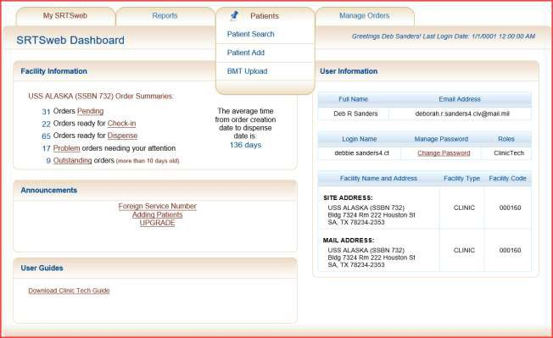

## Patient Search

This screen allows the user to search for patient records stored in the SRTSweb database. The user has the ability to search by patient last name, first name, patient’s identification number or social security number.

SRTSweb will maintain patient data for 4 years after which the records are migrated to an archive database.

Patient can also be searched by typing Identification number into **Quick Search** and pressing Go. **Quick Search** only takes numeric values.

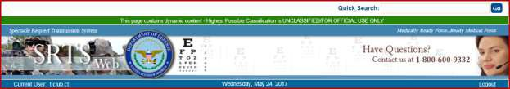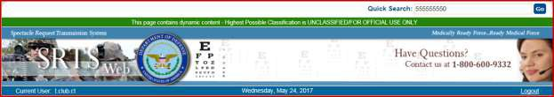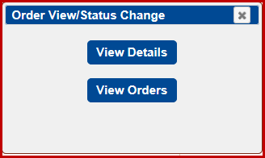

If the patient’s SSN or DOD brings up an existing patient the following screen will be displayed.

Pressing View Details bring up the Manage Patients page. Pressing View Orders brings up the Order Management page.

### NOTE: If patient is not in system the Add Patient screen will appear.

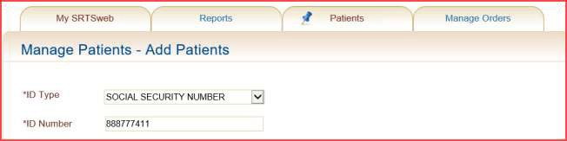

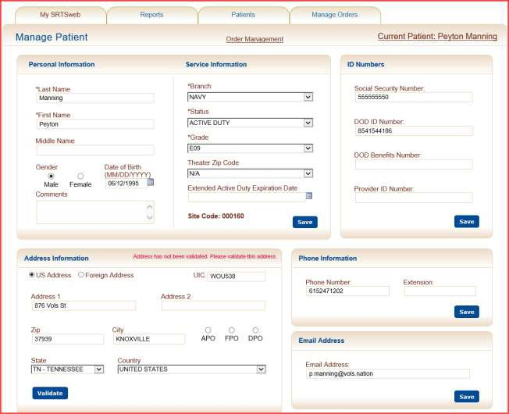

**View Details**

**View Orders**

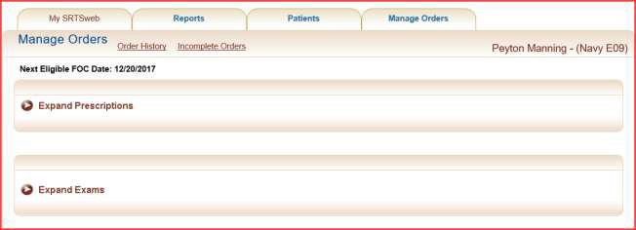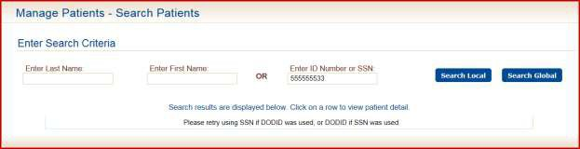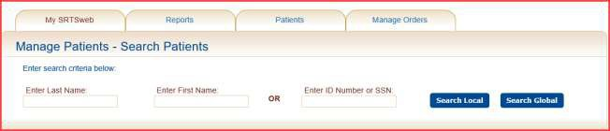

**NOTE: A minimum of 2 characters is required when doing a last name search.**

Patient can also be searched by typing Identification number in Enter ID Number or SSN. If no patient is found a message will appear on screen to retype or use the other ID.

### NOTE: If search local or search global does not locate a patient go to Add Patient.

After the appropriate search criteria have been entered, the search can be performed at the site level or globally by clicking on either the **Search Local** or **Search Global** buttons.

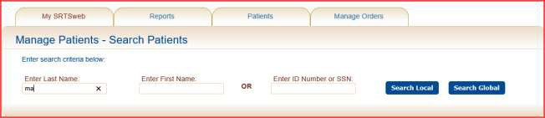

The results of the search are then displayed as a list of patient detail records. The information provided in the returned list includes Last name, First Name, ID Number(s) *Last Four, the Type of ID (‘s), the individual’s Status, the Branch of Service and the Grade.

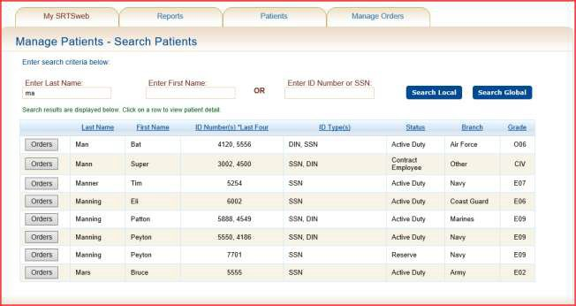

**NOTICE** the option to place **Orders** after searching for a patient. Placing orders will be discussed under **Order Management**.

The user has the capability to sort the grid-views within Manage Patient Search. Click on the column to sort. An arrow will show ascending or descending order.

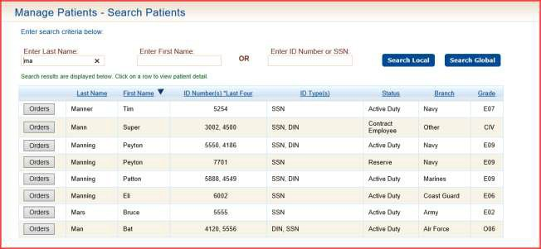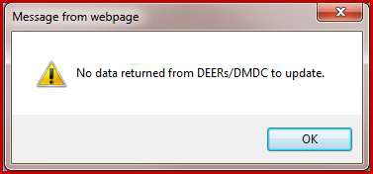

To view more detail data on a particular patient, click on the row of the patient to view patient Personal Information and Contact Information.

### NOTE: Clicking on Orders will take user to the Manage Order page.

The user has the option to update the patient with data out of DEERS/DMDC after opening up their Personal Information and Contact Information page. Clicking on the patient’s name will automatically update.

If no date is returned the user will get a message.

If date is returned the user will see the Original data and the Refresh data. Press **Save** to change the data to the Refresh from DMDC / DEERs.

Any updates in SRTSweb does not go back to DMDC/DEERs.

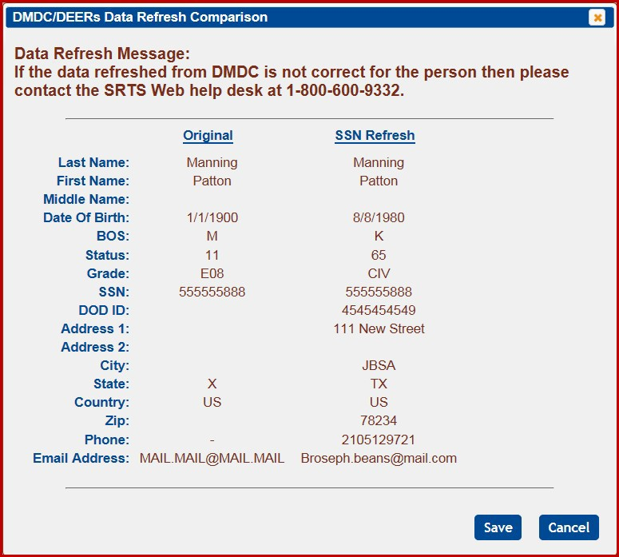

Each section still has the ability to edit data that is currently stored in the database.

### Any updates done in SRTSweb does not go back to DMDC / DEERs.



**Personal Information Service Information**

To update a patient’s Personal and Service Information, go to the Patient’s box that needs to be edited. The user must click on the **Save** button to save the changes.

Fields which may be modified include:

* the last name
* the first name
* the middle name
* the date of birth

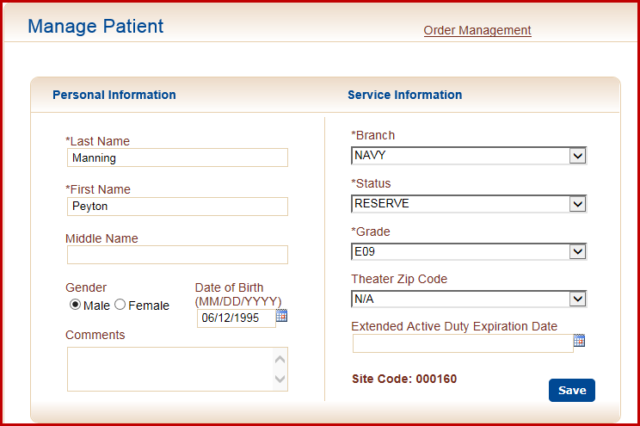

* the Gender
* the branch of service
* the status
* the grade
* the theater zip code (for personnel in combat zones)
* the Extended Active Duty date
* any comments that are specific to the individual

### NOTE: The Site Code displays the clinic the patient was originally added in. This does not affect the order coming back to your clinic.

A confirmation message box will appear if any changes were made.

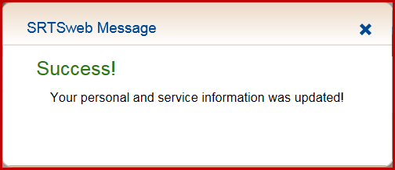

Clicking anywhere on the screen will make the message disappear.

### ID Numbers

An Identification Number record is automatically added when a Patient is initially added to the SRTSweb database. To add or update an existing Identification Number record for an individual, click on the Identification Number detail line.

Only one Identification Number can be added of each type.

Once the data has been entered, click the **Save** button to save the changes.

The user has the option to update the patient with data out of DEERS/DMDC after opening up their Personal Information and Contact Information page. Clicking on the patient’s name will automatically update both Social Security number and DOD ID number.

A confirmation message box will appear.

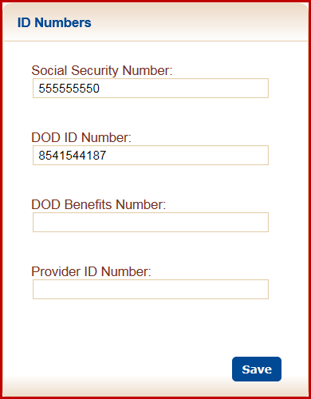

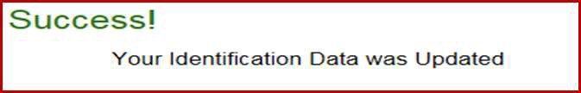

### Address Information

To add or update an address record for a patient, select the Address Information box and add or correct. Press **Validate** when complete.

The required fields to update a Mailing Address screen are:

* Address 1
* City
* State
* Zip Code - Will populate city, state and country appropriately
* Country - The country will default to United States if applicable

The City will default if the APO, FPO or DPO are selected. State dropdowns will default to Area Europe (AE), Area Pacific (AP) or Area Atlantic (AA) for selection.

An address is not mandatory to place an order unless the unit mails the glasses to the patient or if the lab mails to patient. The lab has to be a lab that mails to patients.

If a USPS validated address is selected, the address considered valid for 90 days. If a user overrides the USPS validation, the address is considered as valid for 30 days. If the address is a Foreign Address the address is considered valid for 30 days. A message will pop up after 30 or 90 days to say “Please validate this address” if the order is a Mail to Patient order.

USPS cannot validate the Address 2 line.

USPS can't validate APO, FPO or DPO addresses, these addresses are treated differently. Validation process: Address is presumed valid after pressing **Validate**, and is valid for 30 days. After 30 days, the address popup says "Please validate this address".

Address is compared against USPS data. If marked as "valid" through USPS, validation date is entered.

UIC can be saved by pressing **Validate**.

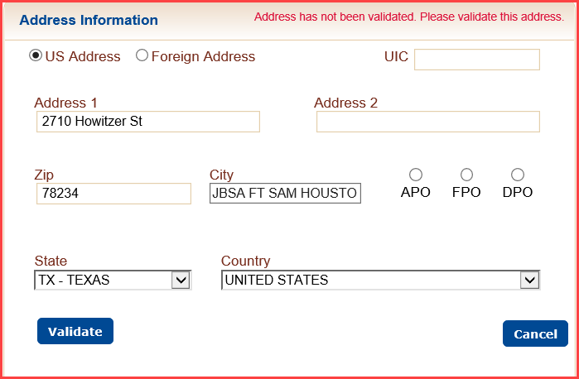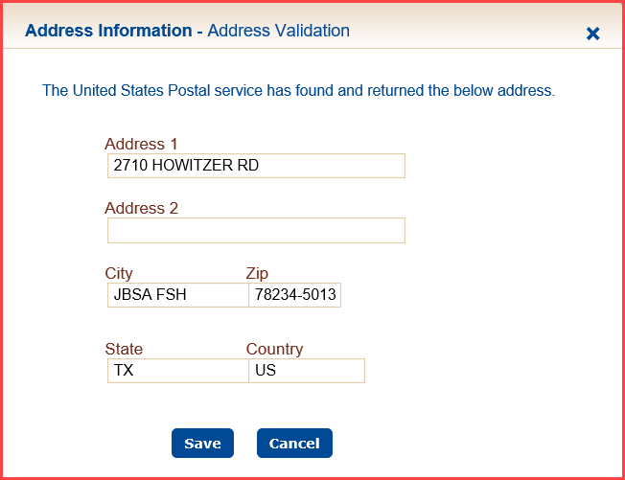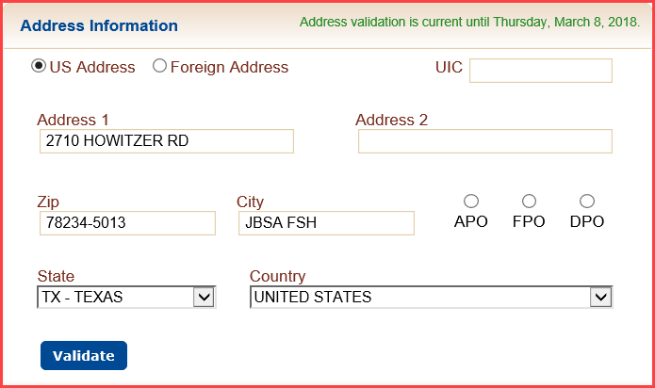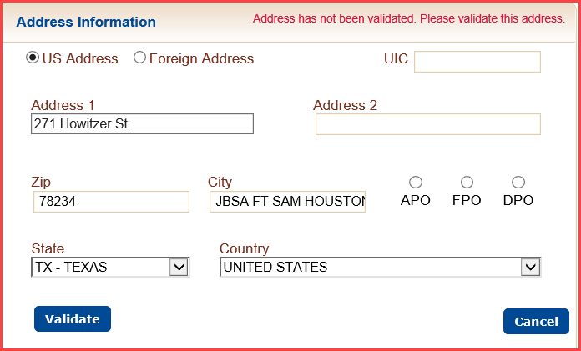

If not "valid", a window is presented with options to **Save Address as Entered** and be validated for 30 dates or **Cancel** to edit the address and validate again.

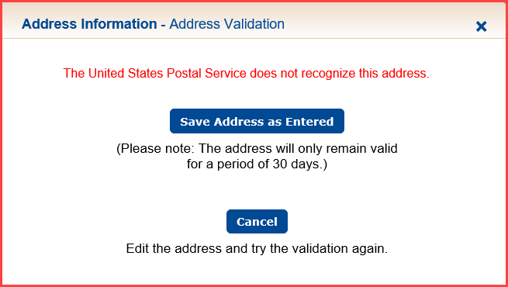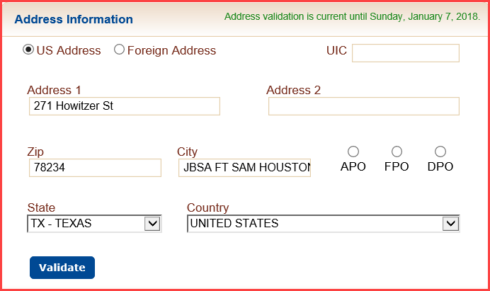

To add a Foreign Address click on the Foreign Address button, add Address 1 and Country.

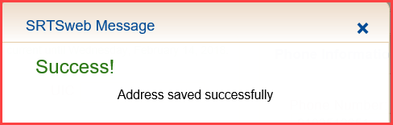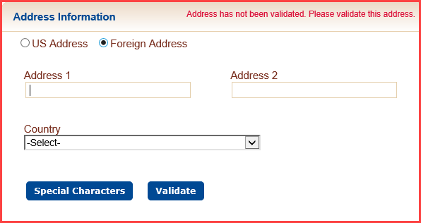

USPS cannot validate foreign addresses, foreign addresses are treated differently. Validation process: Address is presumed valid after pressing **Validate**, and is valid for 30 days. After 30 days, the address popup says "Please validate this address" if the order is a Mail to Patient order.

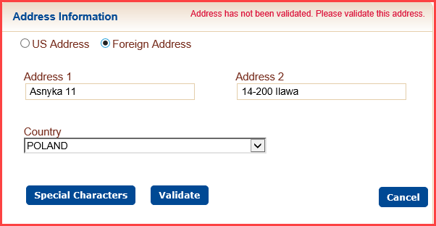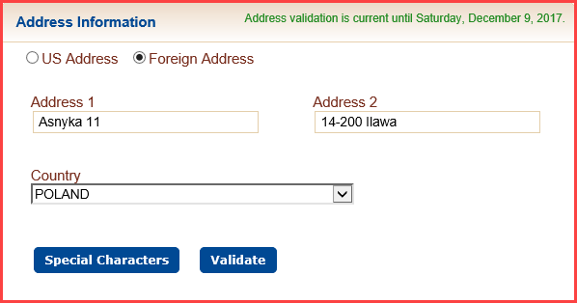

The user has the option of adding Non-English characters in the address field.

Press Special Characters.

Select character and press **Replace** or **Replace All**.

To **Replace** only one character highlight the character and press **Replace.**

When the data entry is completed, click the **SAVE** button to save the record in the SRTSweb database.

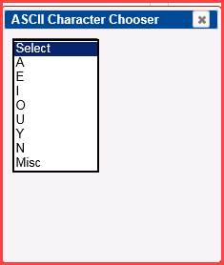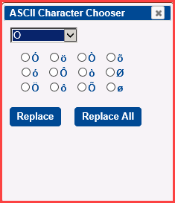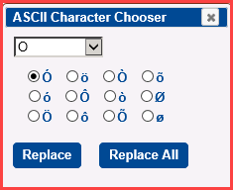

A SRTSweb confirmation message box will appear.

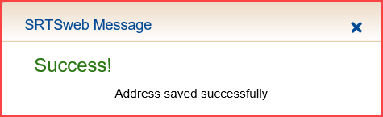

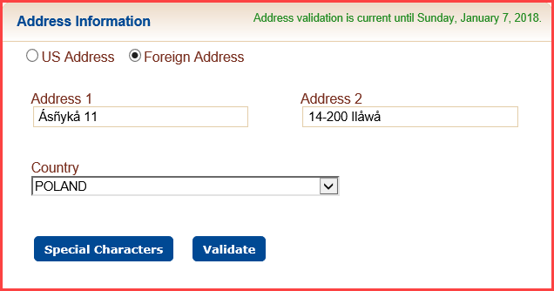

An address will show the special characters.

### Phone Information

To add or update a patient’s Phone Information, go to the Patient’s box that needs to be edited. Click on the **Save** button to save the changes.

If no phone number is located SRTSweb will default one.

### NOTE: There must be an active phone number on file before adding an order.

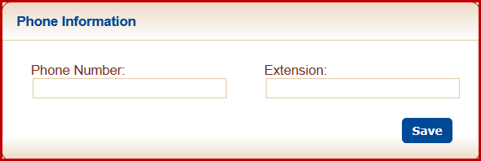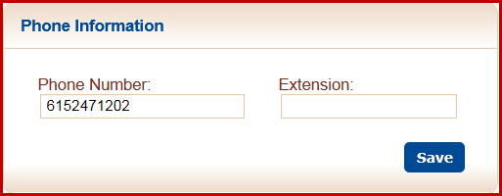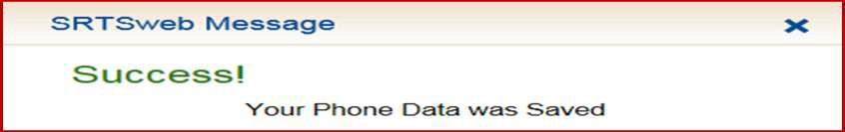

confirmation message box will appear.

A



### Email Address

To update a patient’s Email Address, go to the Patient’s box that needs to be edited. User needs to click on the **Save** button to save the changes.

If no email is located SRTSweb will default one.

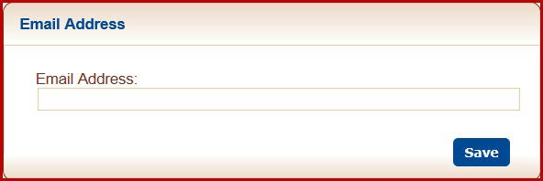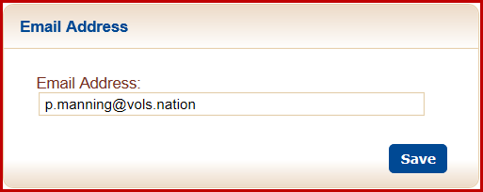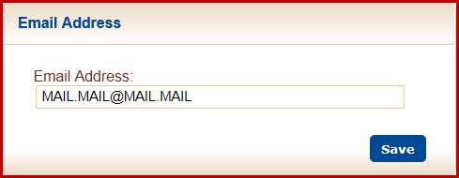

A confirmation message box will appear.

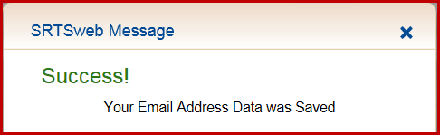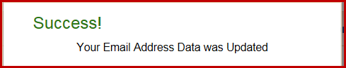

### NOTE: An option to change email address is given on the order screen. Please refer Order Management - Add Order.

**NOTE: An option to change email address is given on the order screen. Please refer Order Management - Add Order – Expand Order Notifications.**

**Order Management**

Click on the **Order Management** on the patient Manage Orders page.

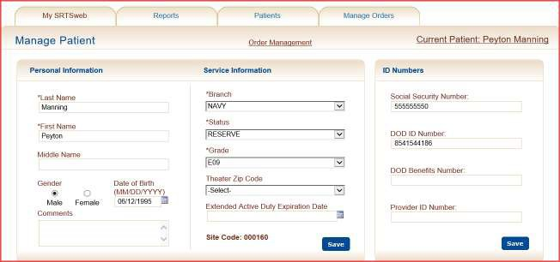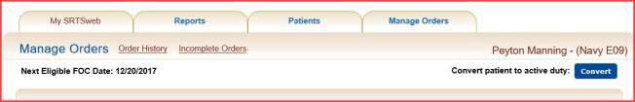

After going into the Order Management tab the user has the option to convert Reserve or National Guard patients over to Active Duty.

Clicking on **Convert** will change the patient’s status to active duty.

**NOTE: Any updates in SRTSweb does not go back to DMDC/DEERs**.

Clicking on the Order Management tab displays 3 sections to view and add information pertaining to patient exams and prescriptions.

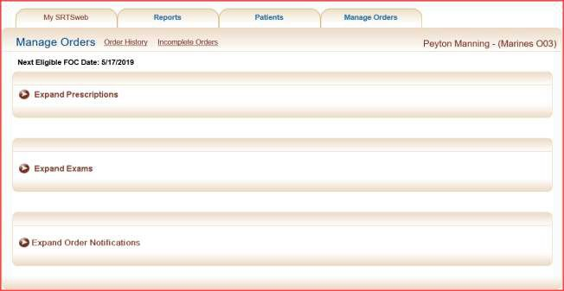

* Exams
* Prescriptions
* Order Notifications

The display areas have “Expand" and "Collapse" arrows to help inform users if the patients' exams, prescriptions and notifications are hidden or visible. Click on the arrow to view or hide the information.

### Exams



Columns for the Exam Date, the Both Corrected acuity information and the Both Uncorrected acuity information of exams on file for the patient are displayed.

To add a new exam record, click on the arrow to expand, click on the **Add Exam.** The user has the ability to tab and use the up/down arrow key after selecting the exam date.

This page displays the following fields for add or edit:

* Exam Date
* Right (OD) Corrected
* Right (OD) Uncorrected
* Left (OS) Corrected
* Left (OS) Uncorrected
* Both Right and Left for Corrected
* Both Right and Left for Uncorrected
* Comments
* Provider’s Name

Click on **Save** or press **Enter** when tab is on Save. To **Cancel** click the X in top right hand corner.

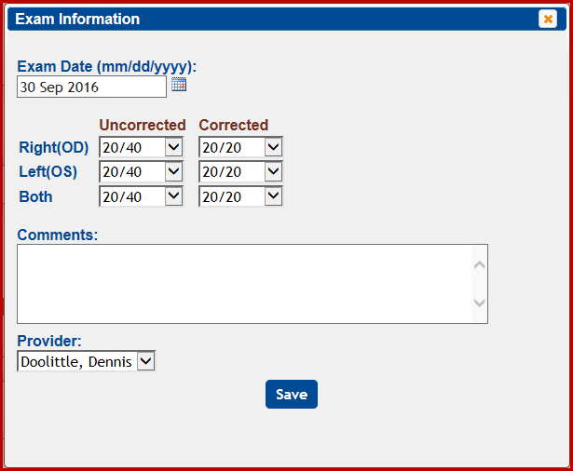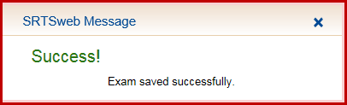

### NOTE: A provider must be added by the Clinic Administrator to show up in the Provider dropdown. Admin can default a provider.

A confirmation message box will appear.

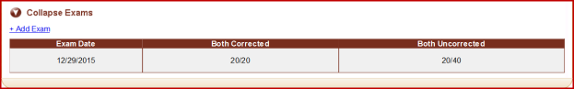

To edit a particular exam, click on the exam record to be updated.

The Edit Exam screen is displayed allowing updates to the selected exam.

Once the updates have been entered, the user can click on **Update** or press **Enter** to record the changes. To **Cancel** click the **X** in top right hand corner.

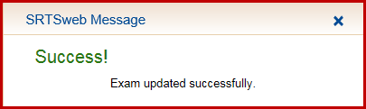

confirmation message box will appear.

A

### Prescriptions

To add a prescription for the selected patient, click on the **Add Prescription**. The Prescription Information screen will be displayed.

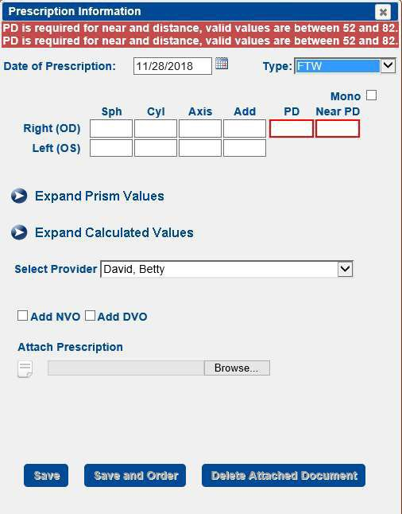

### NOTE: Clinic Admin may have defaulted preferences to the type of prescription. The provider may default to type of RX.

**NOTE: Clinic Admin may have defaulted preferences to add a PD and Near PD or leave the options blank for tech to add in.**

Click on the calendar icon to enter date of prescription



**NOTE: Default date on the prescription date field is the current date.**

### NOTE: A pop-up message displays if date entered is greater (>) than 10 months old.

**This portion of the page displays the prescription information for the patient.**

The type will default to FTW.

The user has the ability to add only a FTW, DVO, NVO or C/O.

* + Distance Vision Only (DVO)
  + Near Vision Only (NVO)
  + Full Time Wear (FTW)
  + Computer/Other (C/O)

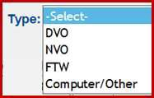

The user has the ability to add the following information: for both right and left values:

* Sphere
* Cylinder
* Axis
* Add
* PD
* Near PD

The user can type and tab in the required fields. To add a negative number type the number and the number defaults to a negative – sign. To add a positive number press the plus sign + before typing the number.

Value must be between -25 and +25, in increments of 0.25.

The PD distance and near can be defaulted by the clinic admin. Clinic Admin may have defaulted preferences to add a PD and Near PD or leave the options blank for tech to add in.

### NOTE: If PD is not present on prescription user needs to measure.

Typing a 60 in the PD will default Near PD down 3 points to 57. User can type in any number between 52 and 82.

The user can change the Mono PD by clicking the box.

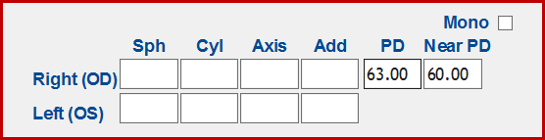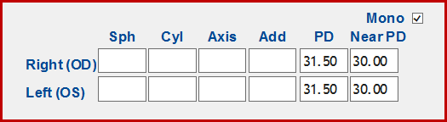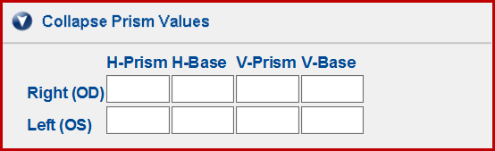

If the user requires a prism in their prescription, the user will need to **Expand Prism Values**. The prism box is defaulted to be collapsed.

* H-Prism
* H-Base
* V-Prism
* V-Base

If the user wants to view the Calculated Values in their prescription, the user will need to

### Expand Calculated Values.

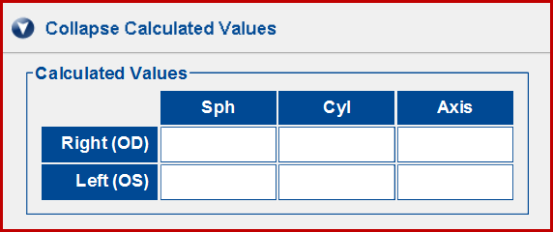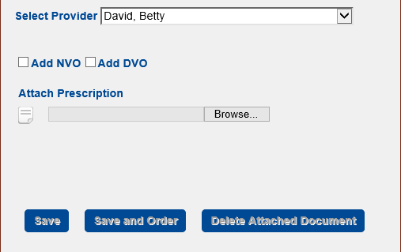

Additionally, the provider that wrote the prescription is selected.

### NOTE: A provider must have been added by the Clinic Administrator before an order can be placed. A provider may be defaulted to type of RX. An Unknown has been added to select if providers are not in your clinic.

The user has the ability to have the system add the NVO and DVO prescription automatically by checking boxes at bottom of Prescription Information.

The user has the ability to upload a copy of the prescription saved on their computer which allows multiple file types. File types are pdf, jpg, gif, png, and tif/tiff.

The document for uploaded documents can be no greater than 5 MB.

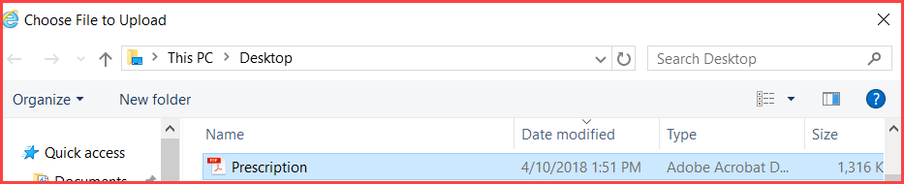

The user has the option to **Save**, **Save and Order, Delete Attached Document by clicking on each one respectively,** or cancel by clicking the **X** in upper right hand corner.

A confirmation message box will appear.

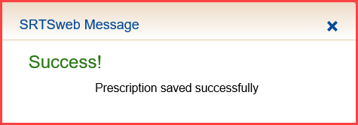

There will be a visual indicator under Doc on the prescription list when there is an associated file. Clicking on the **Doc** visual indicator will enable user to view the saved prescription.

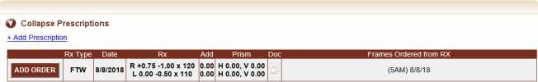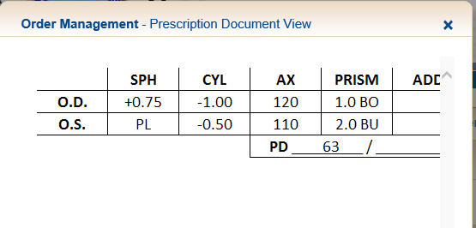

The file will be stored for a minimum of 60 days.

**Save and Order** opens the Eyewear Order Information after saving the prescription.

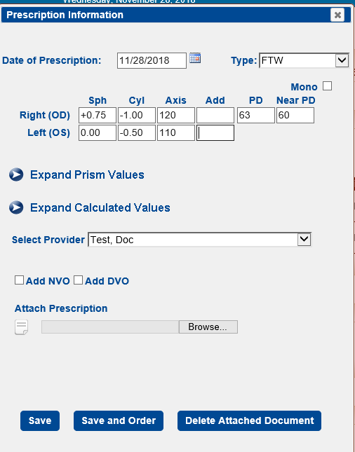

These are examples of the prescription list before and after the Save.

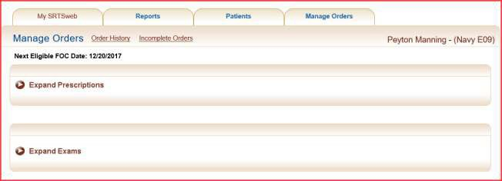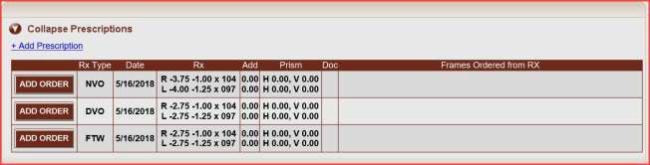

The user has the ability to **Delete** or **Update** the prescription if the prescription has never been used with an order.

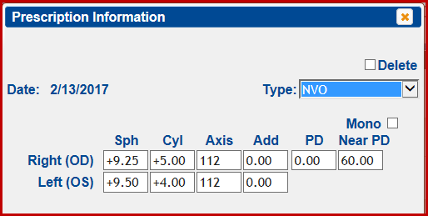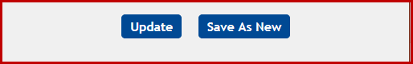

The user has the ability to **Save As New** if prescription has been used and need to be updated.

Frames Ordered from RX will display Frame and Date prescription was used.

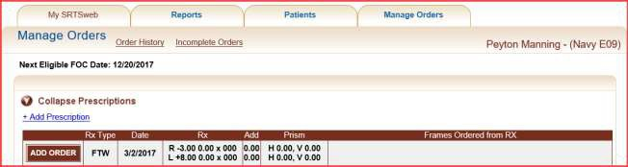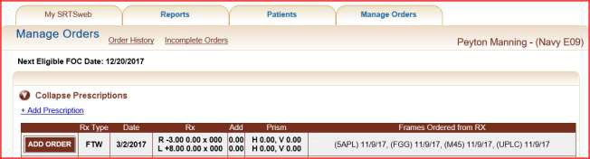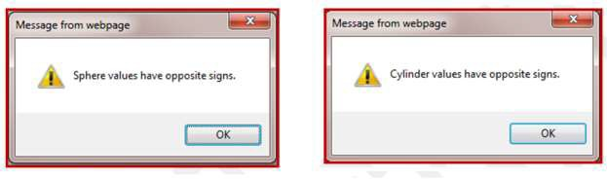

If the prescription has opposition Sphere or Cylinder values a message will appear on the screen to be approved.

When opposite signs are entered and the user verifies that is intended, there is a comment on the order placed for “Opposite signs verified”.

Opposite Signs Verified will also appear on the DD 771 for the lab to verify.

When opposite signs are entered and the user indicates it was an error, no comment regarding opposite signs is placed.

When High Power Lens (HPL) is a factor, sphere and cyl are greater than or equal to plus (+) or minus (-) 6 (six) in any meridian the material will default to High Index. No material justification will be required.

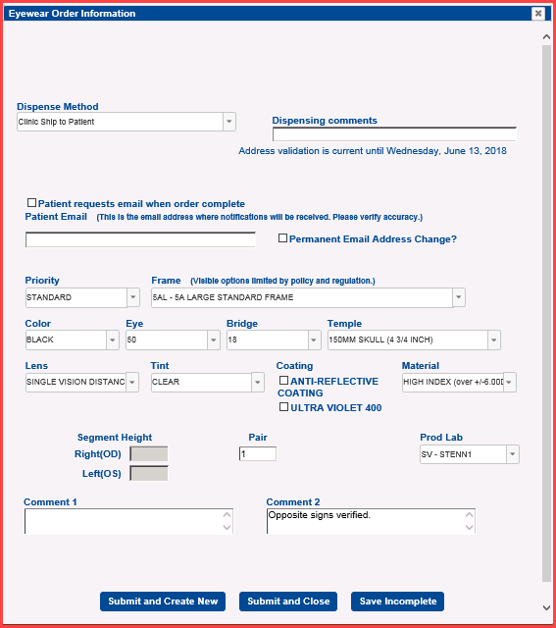

When an order for anything other than MCEP inserts has one or more HPL, Hi Index is selected.

When an order for UPLC is placed, polycarbonate is selected, regardless of power.

### NOTE: When Sphere or cylinder are -/+ 3 certain FOC frames are not allowed to order.

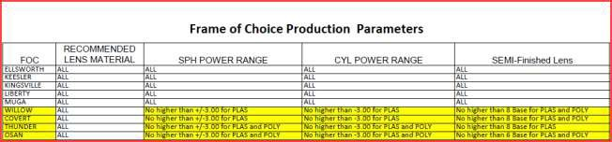

**Add Order**

The user has the ability to select an appropriate prescription to be used for an order by clicking on the **ADD ORDER** button in front of the RX Type.

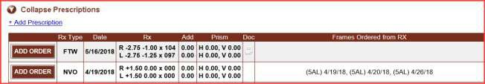

The user has the ability to go straight to Order Management page to place an order by selecting the **Orders** button from the Patient Search screen.

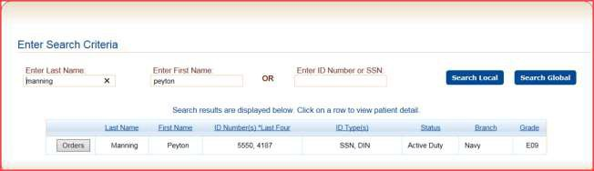

The user has the ability to place an order by selecting the **Save and Order** button from the Add Prescription screen.

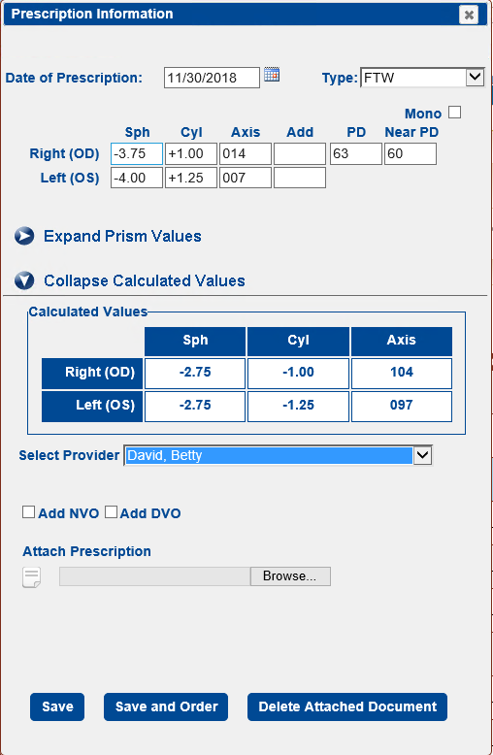

The user has the ability to select option, select by drop down arrows or typing in portion of selection.



### NOTE: The clinic admin has the option to have some options defaulted when tech’s are placing orders; the priority, frame, lab, distribution and initial order preferences. These preferences will allow the screen to default. These options can be changed to meet the order the user needs.

**NOTE: The clinic is defaulted a single and a multi vision lab. The labs have the option to set preferences of the prescription they can fabricate. If the clinic adds a prescription that their assigned lab cannot make the order will automatically go to NOSTRA.**

To go between fields the user can click on option or tab between fields. This information includes:

* Dispense Method
* Dispensing Comments
* Patient’s Email
* Priority
* Frame
* Color
* Eye
* Bridge
* Temple
* Lens
* Tint
* Coating
* Material
* Segment Height
* Pair
* Production Lab
* Comments

The user has the ability to select a Dispense Method. Clinic Distribution, Clinic Ship to Patient or Lab Ship to Patient. If patient does not have an address the clinic distribution will default. Clinic Admin can default the dispense method.

The user has the ability to select a **Dispense Method**. Clinic Distribution will be the default.

Clinic Ship to Patient and Lab Ship to Patient will not show if the patient does not have an address.

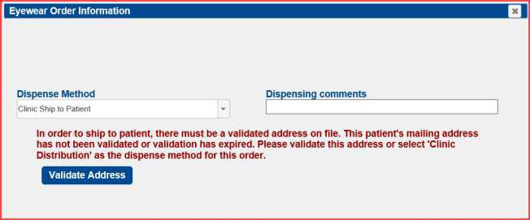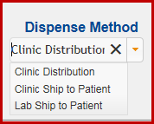

### NOTE: Address must be validated before Clinic Ship to Patient or Lab Ship to Patient.

Clinic Ship to Patient will produce a mailing label at the clinic. After checking in order an option is displayed at the bottom of the screen to Open or Save a mailing label.

### If no action for printing or saving the label at this time is taken then a mailing label can be reprinted under Reports – Manage Reports – Reprint Shipping Labels. The reprint option is good for 7 days. The clinic admin has the option to select labels be printed alphabetically.

**Under reports – Manage Labels the user has the ability to add orders that were not marked as Mail to Patient by typing, scanning in a single order number and pressing Add Order or Bulk Input and Add.**

The user has the ability to add a Dispensing comment that will be displayed at the top of the DD 771. The dispense comment does not affect the order. A total of forty five (45) characters are available.

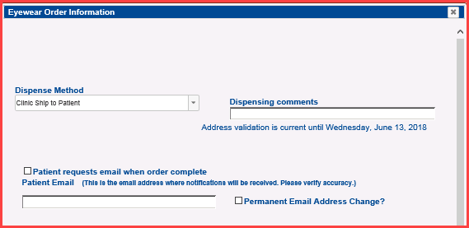

The user has the ability to select to have an email sent to the patient when order is complete. User also has option to change email address.

User must check the box that indicates whether the patient would like an email “Patient request email when order complete” before completing the order.

User also has option to change permanent email address.

If the user selects email notification, the patient receives appropriate communication.

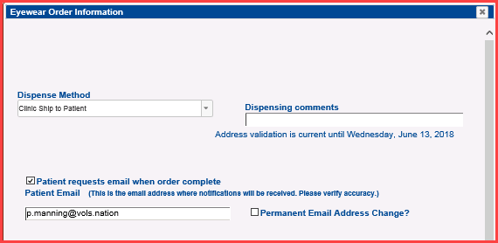

* If the order is “Lab Ship to Patient”, upon completion of order an email will be sent.

Your order for HLF50, CL has been completed. Orders are typically mailed within 1-2 days after completion. If you no longer want to receive these emails please email the Global Service Center at [dhagsc@mail.mil](mailto:dhagsc@mail.mil)

* If the order is “Clinic Ship to Patient”, upon completion of order an email will be sent.

Your order for HLF, CL has been completed. Orders are typically mailed within 1-2 days after completion. If you no longer want to receive these emails please email the Global Service Center at [dhagsc@mail.mil](mailto:dhagsc@mail.mil)

* If the order is “Clinic Distribution”, upon completion of order an email will be sent.

Your order for M45, CL has been received at the clinic. Please follow the guidance given to you when you placed the order, or contact your clinic for details. If you have multiple orders, please contact the clinic to ensure that they all have arrived. If you no longer want to receive these emails please email the Global Service Center at [dhagsc@mail.mil](mailto:dhagsc@mail.mil)

The user has the ability to view emails under Order Notifications.

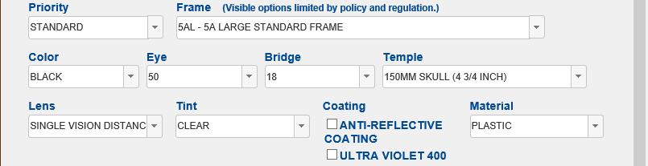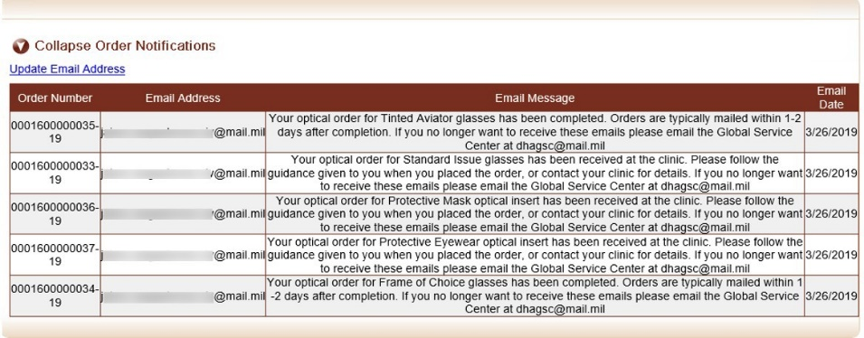

When the user selects a frame a default will be automatically selected. All other valid options are still available for selection.

User has the ability to select “Coating” options:

* Anti-Reflective (AR) coating
* Ultra Violet 400

User must enter justification in the ‘Coating Justification’ box

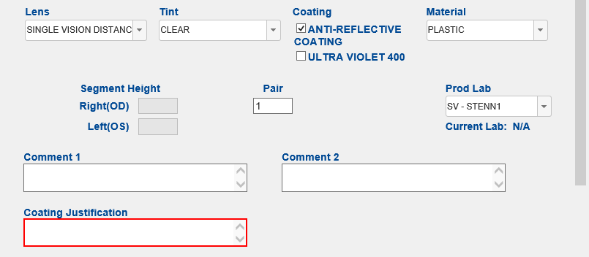

NOTE:

1. Coating Justification box displays below Comment 1 box
2. Justification must contain three or more characters
3. No action allowed if justification is less than three characters
4. User will either enter complete justification or de-select coating option to complete order

### NOTE: The Segment Height will be grayed out if no ADD Power has been added to the selected prescription.

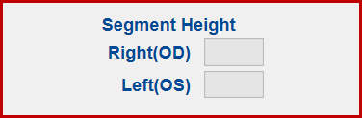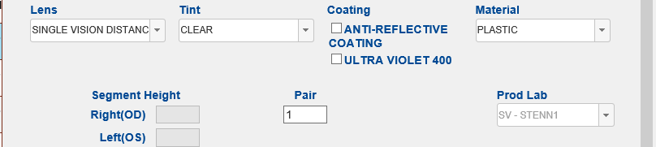

**NOTE: The only Lens will be Single Vision only if no ADD Power has been added.**

**NOTE: The Prod Lab field will be grayed-out. Lab selection for single or multi vision lab corresponds to type of lens selected in Lens selection field**

**Submit and Create New** gives the user the ability to submit an order and have a new prefilled order show up with the same prescription. This gives the user the ability to change a feature on the screen and order without leaving the screen.

Examples are ordering 5AL with Clear tint, 5AL with N-31 tint, changing Priority to FOC, changing back to Standard, changing frames (M series) and UPLC ordering within seconds. Never leaving the Order screen, the user can order from same RX until **Submit and Close** is clicked.

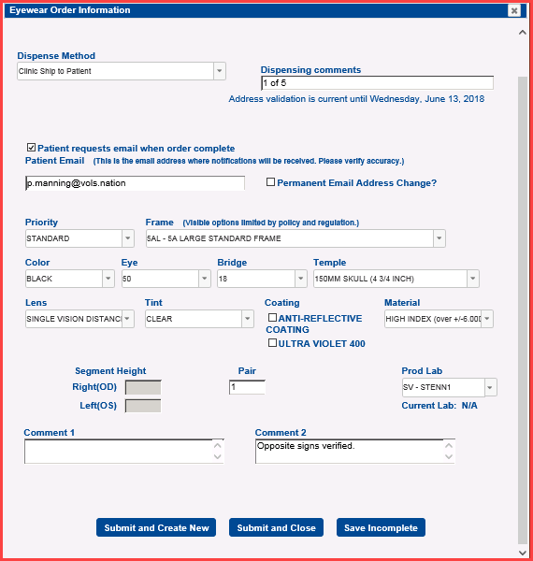

A message appears **showing** the order was saved and allowing user to create new order**. NOTE: Clicking on the page anywhere will make the message disappear faster.**

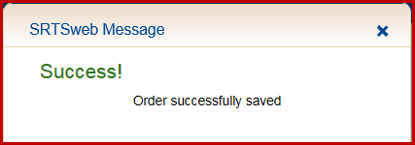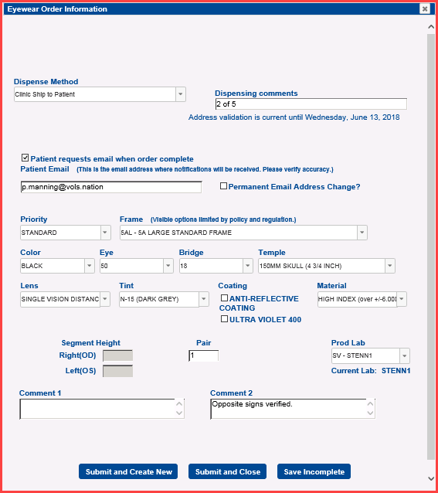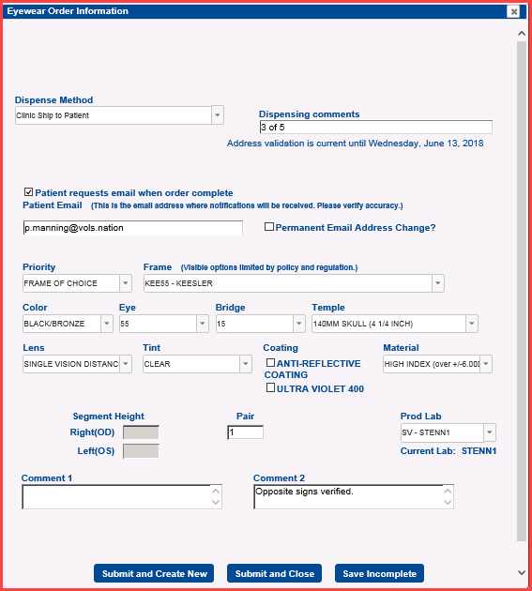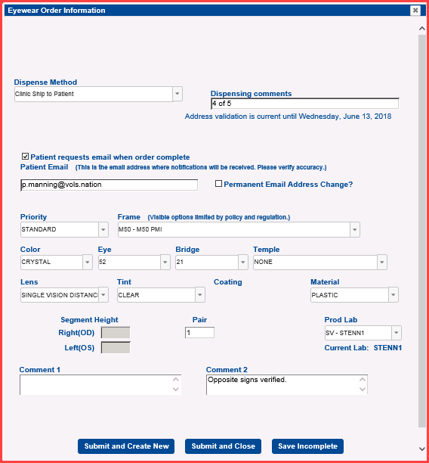

The user needs to **Submit and Close** on last order.

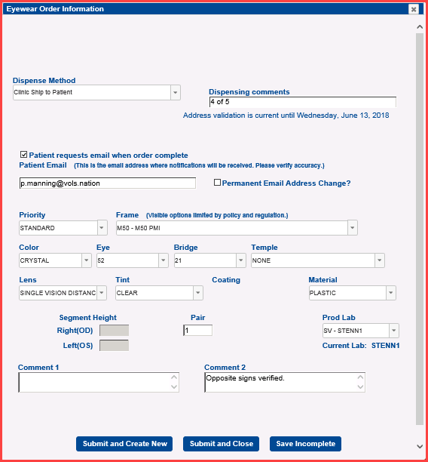

The user has the ability to order the patient multiple pairs of the same order by placing a quantity of 2 in the **Pair**. This will give the order two different order numbers.

### NOTE: This feature only works on Priority and Frame authorized for 2 pair.

If the user places an order of the same order by selecting **Submit and Create New or Submit and Close** within the last 30 days of that order without making any chances (frame, tint, etc.) the user must select a reason for Re-Order.

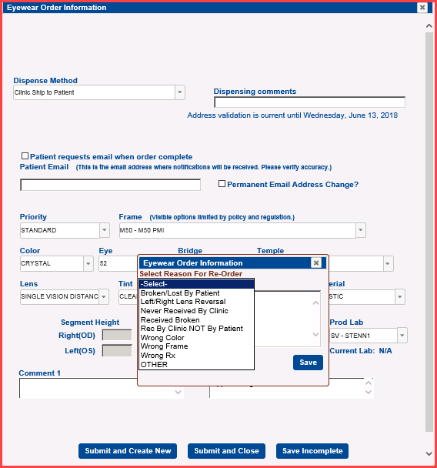

Comments are required to reorder if within 30 days. The comment box is mandatory and requires 5 letters if OTHER is selected. The comments are saved in Comment 1 or Comment 2 box.

Reasons for Re-Order:

* Broken/Lost By Patient
* Left/Right Lens Reversal
* Never Received By Clinic
* Received Broken
* Received By Clinic NOT By Patient
* Wrong Color
* Wrong Frame
* Wrong Rx

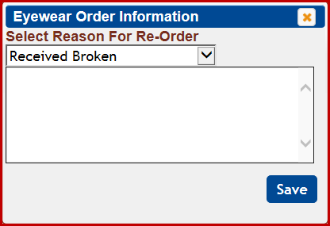

* Other

The user will receive a new Order Number to be sent to the lab.

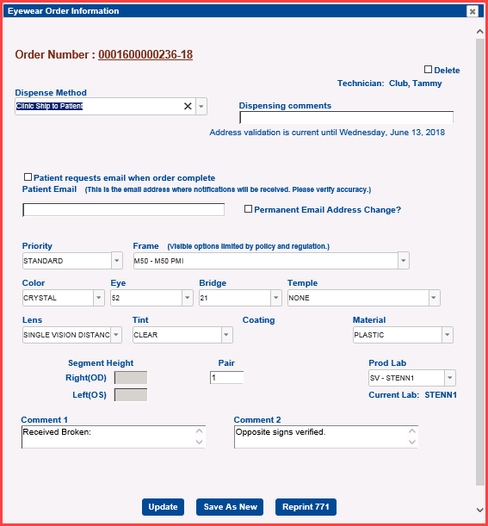

### Incomplete Order

The user has the ability to save orders as **Incomplete Orders** when adding an order. If the user is unsure of the order or has to close unexpectedly the order can be saved as Incomplete. Incomplete means the user still has ownership of the order and the lab cannot pick the order up.

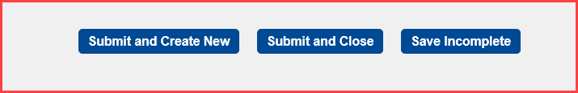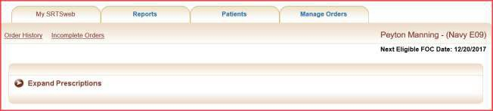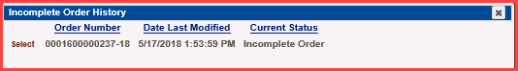

The user has the ability to open an **Incomplete Order** to **Update** or **Delete** the order by clicking the link **Incomplete Orders** above prescriptions. Incomplete orders also go into

**Problem Orders**. Problem orders are discussed under **Manage Orde**r**s.**

Press the **Select**.

**Save** as needed by pressing **Update** or check the **Delete** box in right hand corner.

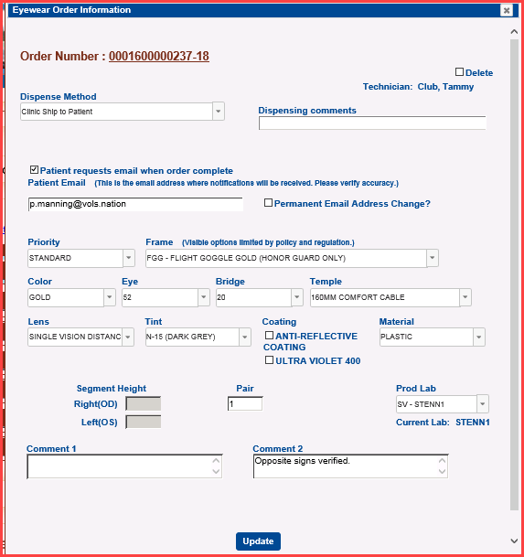

### Order History

The user has the ability to open an order and check the order status history by going to the

**Order History** link above prescriptions.

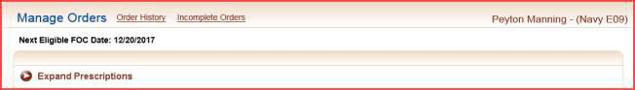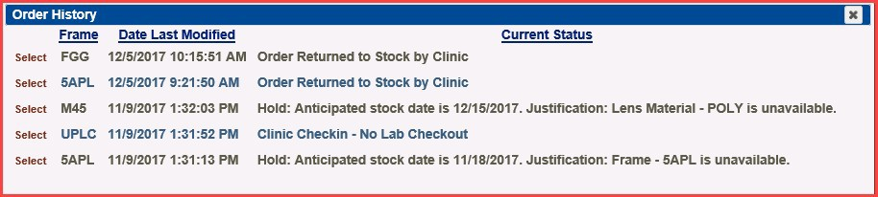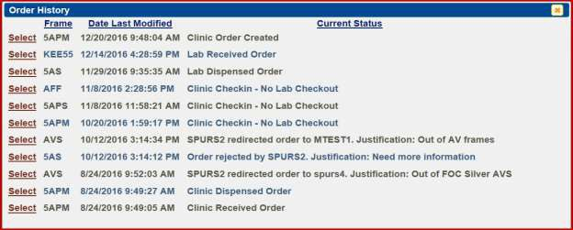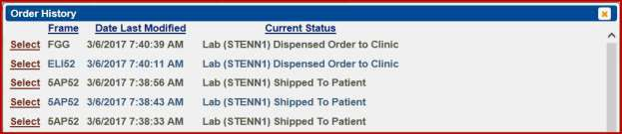

Select an order number.

Hovering over the order number gives the user status details on that order.

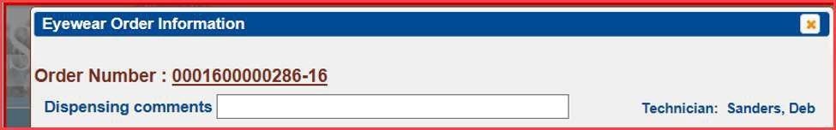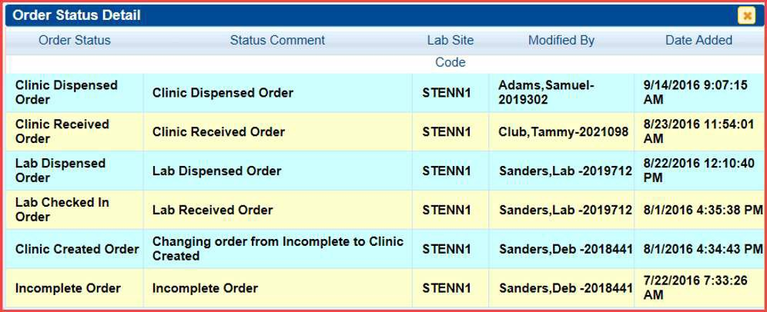

The user has the ability to change the order as long as the status has not left the clinic.

Depending on the Order Status, which is displayed on the right side of the screen next to the Order Date under **Order History**, update of the order record is allowed as follows:

* Clinic Created Order – Order is still at the clinic and may be updated, save as new, deleted or reprint the DD-771.
* Clinic Check-in – No Lab Check Out – Order cannot be updated. User can saved as new or reprint DD-771. Order can be Returned to Stock.
* Lab Rejected Order – Order may be updated, save as new, deleted or reprint the DD- 771.
* Clinic Dispensed Order – Order may not be updated but can be saved as new and reprint the DD-771.
* Clinic Dispensed Order “Forced” – Order may not be updated but can be saved as new and reprint the DD-771. Order can be Returned to Stock.
* Clinic Resubmitted Order – Order is still at the clinic and may be updated, saved as new, deleted or reprint the DD-771.
* Lab Received Order – Order cannot be updated. User can saved as new or reprint DD-771.
* Lab Dispensed Order – Order cannot be updated. User can saved as new or reprint DD-771.
* Lab Shipped to Patient – Order cannot be updated. User can saved as new or reprint DD-771.
* Hold: Anticipated stock date is 12/22/2017. Justification: Frame - 5APL is available.

Order cannot be updated but can be checked in.

* Order returned to stock by clinic – Order cannot be updated but can be dispensed.

### Patient Add

When the user selects this tab, they are directed to the Enter New Patient Information page.

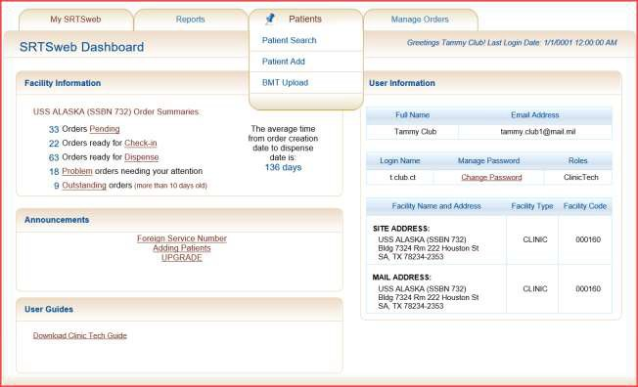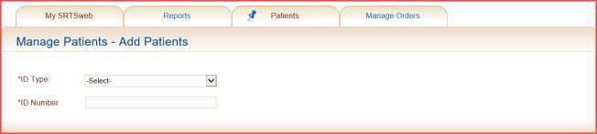

Select the ID type:

* Social Security Number – 9 digits
* DOD ID Number – 10 digits
* DOD Benefits Number – 11 digits
* Provider ID Number - 11 digits

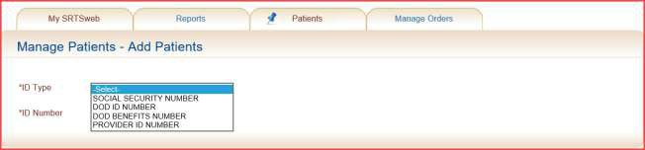

Press **Enter** after entering an appropriate identification number for the new patient. Until all of Legacy patients are migrated over use **SSN** to add patient.

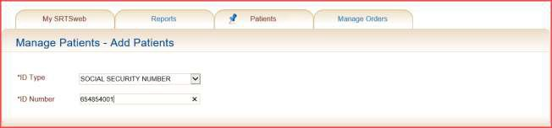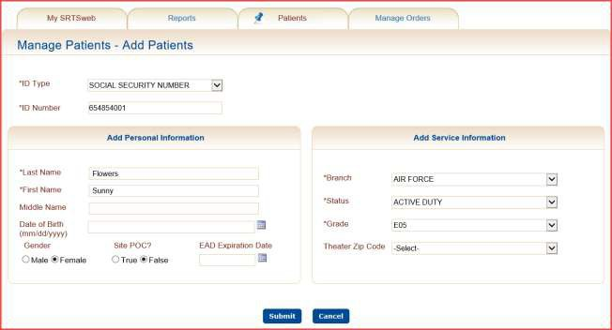

When adding a new record DMDC will default the patient’s information.

### NOTE: If DMDC goes down, add patients with SSN.

The user then has the opportunity to **Submit** the data or Cancel the operation and return to the home page.

If the ID Type is a duplicate ID the patient will be displayed. Click on the **View** button to open record. The View button shows the ID number belongs to a patient that has been added to SRTS previously.

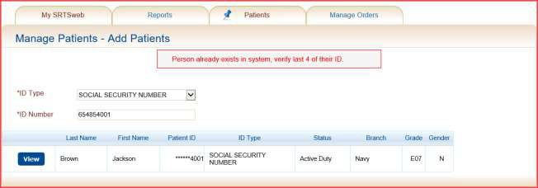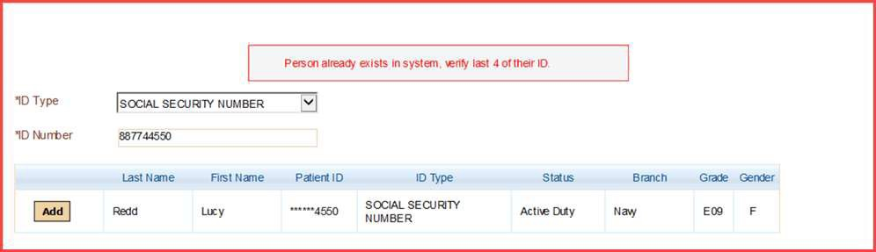

If the ID Type is a duplicate ID the name will be displayed. Click on the **Add** button to open record. This patient has an individual record but not a patient record.

After submitting the record the screen goes to the Manage Patient and the user can update the record or start ordering. Ordering for a patient is discussed in the **Manage Patient – Patient Search** section.

Updating a patient’s record is discussed in the **Manage Patient – Patient Search** section.

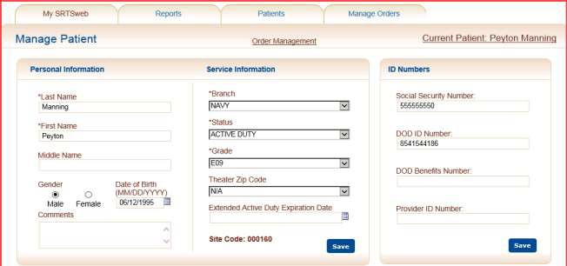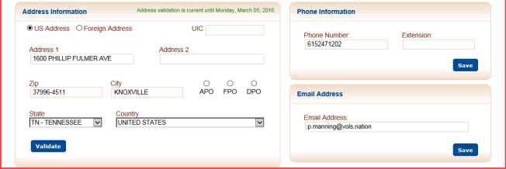

## BMT Upload

This tab will begin a process to upload a file of patient records for soldiers who are in Basic Military Training (BMT). This program automates adding multiple patient records electronically in a formatted CVS file received from users at Basic Military Training/Recruit Training Sites.

This process is a two-step process, retrieve the file and process the file.

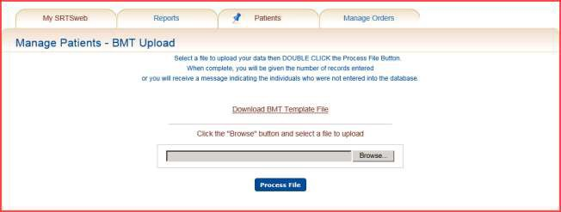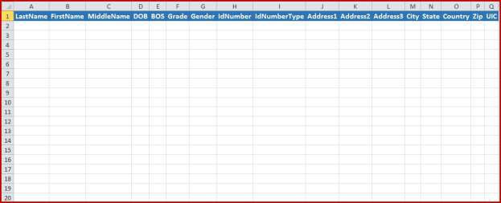

Columns names must match on spreadsheets. Order of columns doesn’t matter. Examples are:

DOB – mm/dd/yyyy BOS

A - Army

F - Air Force N - Navy

M - Marines

C - Coast Guard Grade – 3 digits/characters Gender

M - Male

F - Female

ID Number – numerical ID Number Type

SSN – Social Security

DIN – Department of Defense (DOD) Address

Blank

Address 1, City, State, Country, Zip

**NOTE:** BMT does not interface with DMDC.

When the **Browse** button is selected, a Windows Explorer screen is opened for the user to Browse and select a file to upload. After selecting a file, click on **Open** to select the file for processing. The selected file may then be uploaded into the SRTSweb database by pressing the **Process File** button.

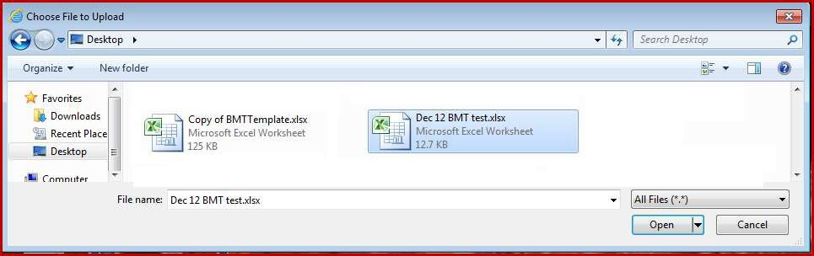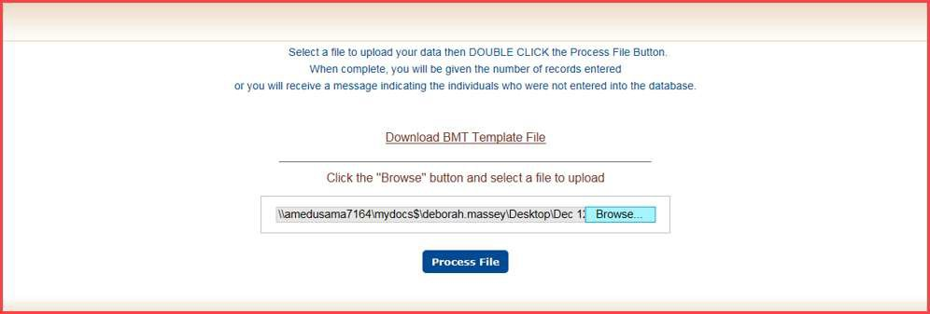

After processing, the screen will display the count of patient records that were uploaded. The screen will also display the count of patient records that were not uploaded.

The unit’s address is assigned to patient address field if address is added. The phone number and email address values for the uploaded records will require updating.

The screen will display the records that failed.

The user has the option to **Download BMT Template File**.

The system will prompt you if there are error(s).

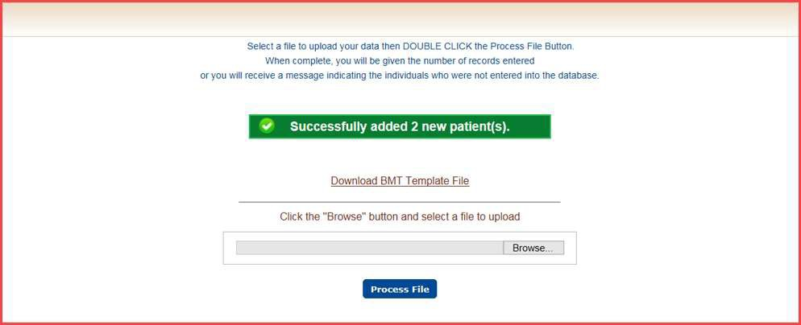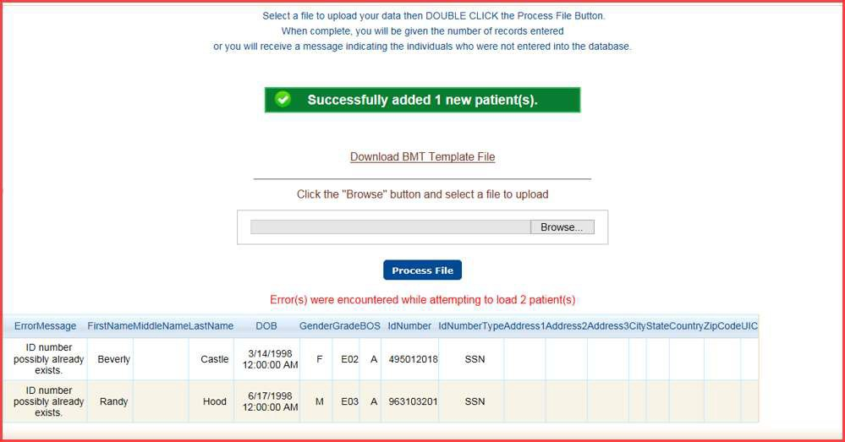

# Manage Orders

### Clinic Order Management

Options displayed under the Clinic Orders Management tab are based upon the user role and include operations pertaining to management of patient demographics and their activities:

* **Pending** - enables the user to check-in orders
* **Check-In** - enables the user to check-in orders from the lab

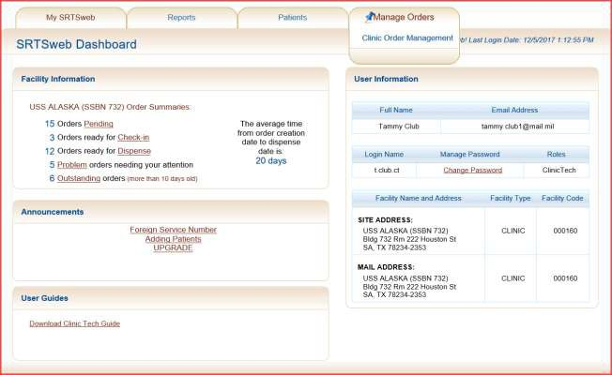

* **Dispense** - enables the user to dispense glasses to patient
* **Problems** - enables the user to work orders that need attention
* **Outstanding** - enables the user to follow up on orders older than 10 days The user has the option of selecting the same tabs from the dashboard.

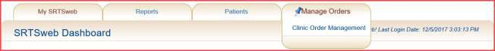

**Pending**



When selected, this process will display a list of all orders that have been created by the clinic and received by the Lab. These orders can be under Clinic Check-in, Problem or Outstanding. These orders can also be Lab Received and not dispensed from the Lab.

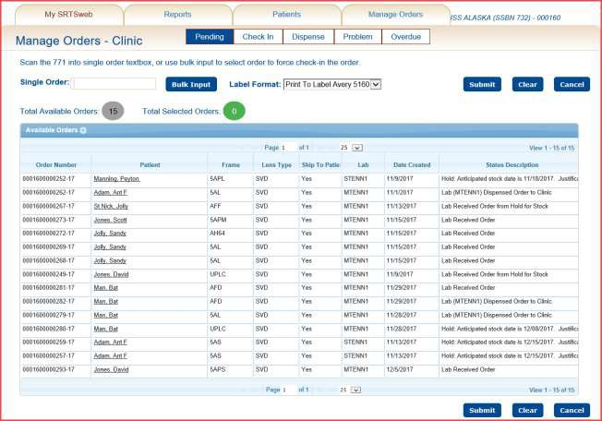

Orders can be checked in from the Pending list by typing or scanning order number in a single order or bulk input.

The fifteen (15) orders showing are Check In - Lab Dispensed to Clinic – 3 Problem – Hold at Lab – 4

Lab Received Order - 8

Type or Scan in order number and press **Enter.**

Bulk Input press **Done**.

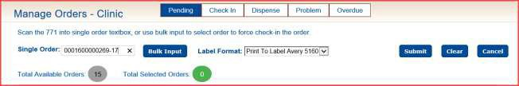

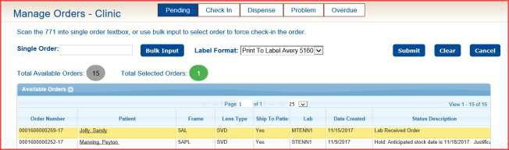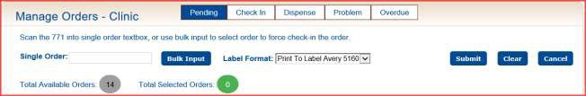

Order number is highlighted. Press **Submit** to process.

Label will print if order has a distribution method of Clinic Ship to Patient.

This order “Lab Received Order” could be one received by clinic but never dispensed by lab. After checking in order status will be “Clinic Check-in – No Lab Checkout.

Total Available will now be 14 on the Pending.

### NOTE: Orders can still be processed under Check In when received by Clinic.

**Check-In**

When selected, this process will display a list of all orders that have been completed through the production process. These orders have been dispensed from the lab and shipped back to the clinic to be checked in and dispensed to the patient. When an order arrives at the clinic, the order must be checked-in to indicate the clinic has received the order.

### NOTE: Orders show up in Check-In when the Lab dispenses them. Do not check in until order is received.

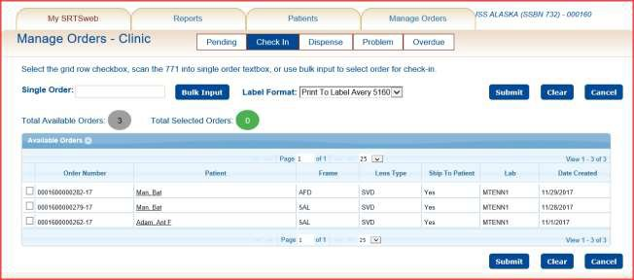

Once an order has been checked-in, the Total Available Check-In count displayed at the top

of the screen is recalculated and the updated count is displayed.

There are 4 methods to process these received orders:

* the user may type an order number into the single order field
* the user may scan the bar code on the order documentation which represents the order number in **Single Order** or **Bulk Input**
* the user may locate the order in the list of active orders and checking box
* the user may type order number into **Quick Search** and press Go or Enter

**NOTE: Orders can also be checked in under Pending.**

The user has the capability to click on a patient name and be taken to the patient’s information page to research patient or order information. If orders are checked a message will allow you to check in or go to patient detail page.

The user has the capability to sort the grid-views within Check In order search. Click on the column to sort. An arrow will show ascending or descending order.

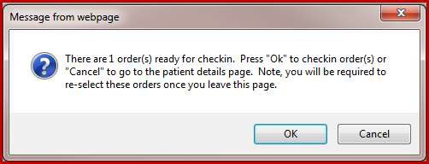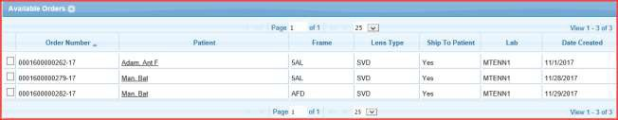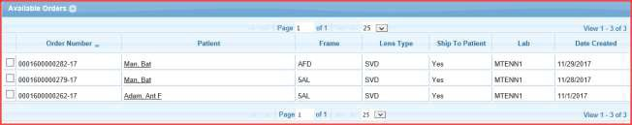

The information provided in the returned list includes Order Number, Patient, Frame, Lens Type, Ship to Patient, Lab and Date Created.

Once the order records are displayed, the user may click on the check box corresponding to the order to be processed. The user should select a **Label Format** on which the active Patient Address will be printed from the drop down list provided if the **Ship To Patient** field value is **Yes**. If the orders are ship to patient a box will appear at the bottom of page to open or save after submitting checked in orders. These are the addresses for shipping to patient**.**



Click **Submit** to check in the orders.

The user will get another message when closing the pdf.

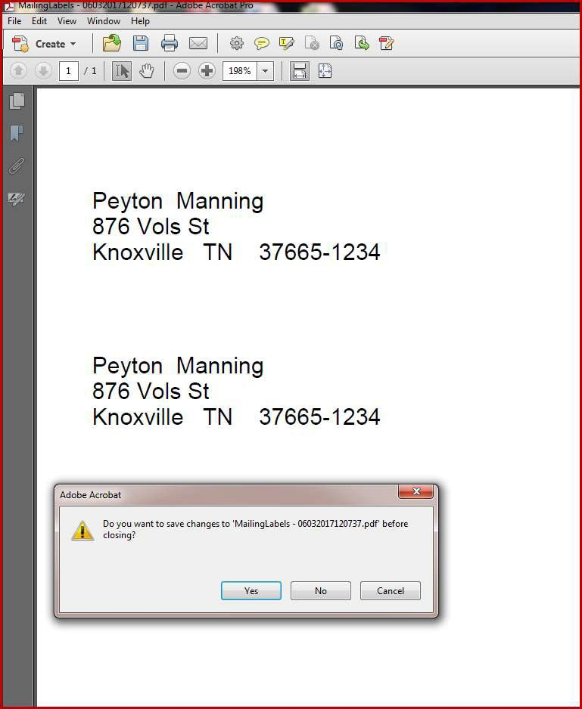

### NOTE: If no action for printing or saving the label at this time is taken then a mailing label can be reprinted under Report – Manage Reports – Reprint Shipping Labels.

**The reprint option is good for 7 days.**

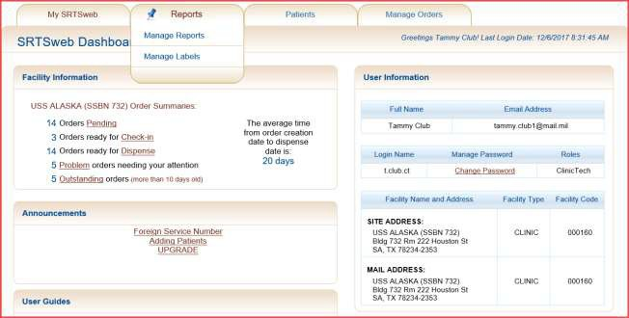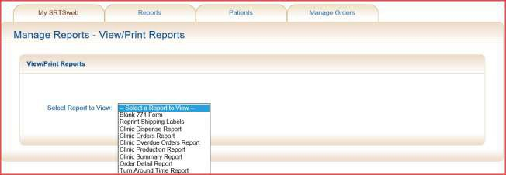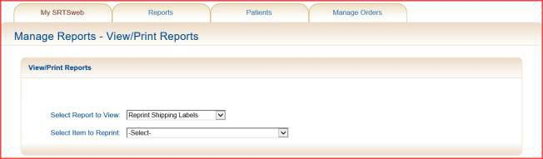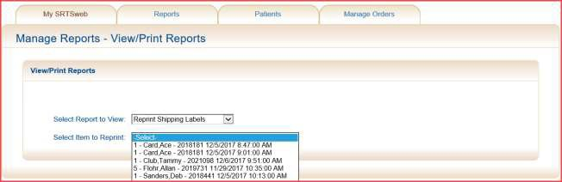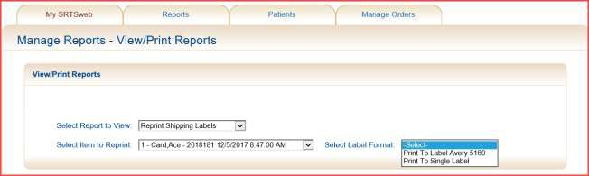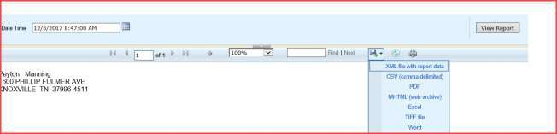

After user selects Label Format the report will start processing. Print using Export Drop Down Menu.

### NOTE: If no action for printing or saving the label at this time is taken then a mailing label can be reprinted under Report – Manage Labels – History. The reprint option is good for 7 days.

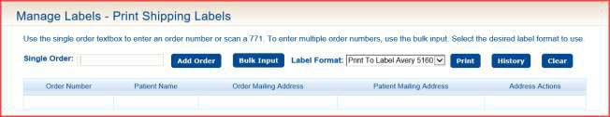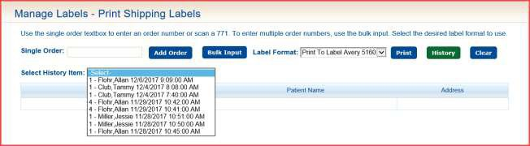

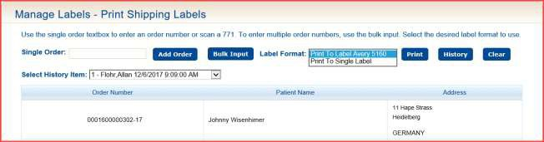



**NOTE: History labels cannot be update. User must type in order number and press**

**Add Order.**

The user has the ability to print Labels for Clinic Distribution orders.

The user has the ability to select patient order address or mailing address. The ability to

Update or Delete record.

**NOTE: More information can be found under Reports – Manage Label section.**

**Single Order**

To check in a single order type in the order number in the box and press enter. The order will go the top of the list and be highlighted in yellow. The user can use the single order number as many times as needed.

The **Total Available Orders** show all orders ready for Check In. The Total **Selected Orders**

will count the number of orders selected to check in.

### NOTE: If the columns are rearranged in any other format the orders will not be pulled to the top of the list.

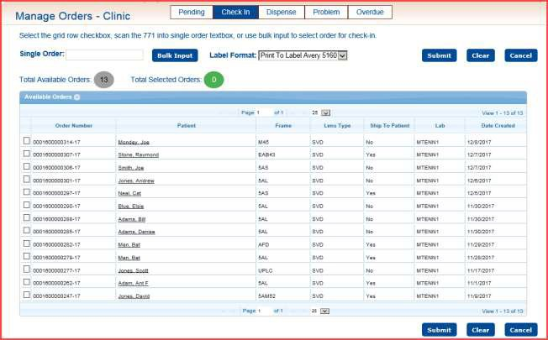

Press **Submit** to check in the orders.

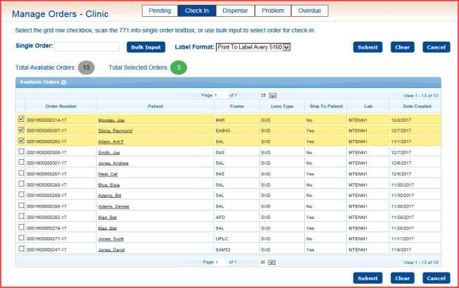

## Bulk Input

Once the order records are displayed, the user may click on the check box labeled **Bulk Input.** The Bulk Order Input box appears. The order number will appear after you scan the order. After scanning the check in box will be checked. Click **Done** when finished and then **Submit** to check in the orders.

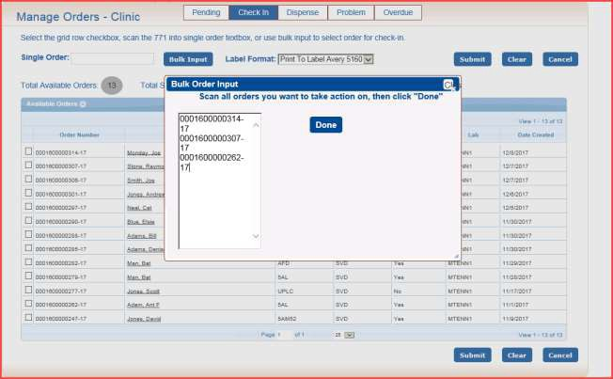

The system will total the record counts and update the screen display with the new number of orders available for check-in. Total Selected Orders will update as order number is selected.

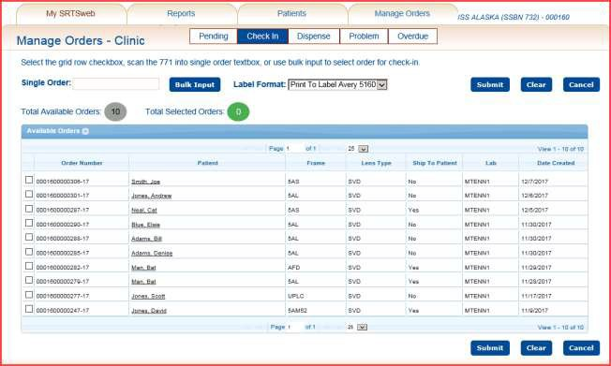

Once the data entry has been completed, click on the **Submit** button to process the order.

The order status will change to **Received by Clinic** and the order is now available to be dispensed to the patient.

If the order is to be shipped to the patient, an option is displayed at the bottom of the screen to Open or Save a mailing label.

### NOTE: If no action for printing or saving the label at this time is taken then a mailing label can be reprinted under Report – Manage Reports – Reprint Shipping Labels.

**The reprint option is good for 7 days.**

**The clinic admin has the option to select labels be printed alphabetically.**



**Locate Order**

The user has the option to find the order number in the grid and check the box. Order will be moved to the top of the list and highlighted. Press Submit to check in.

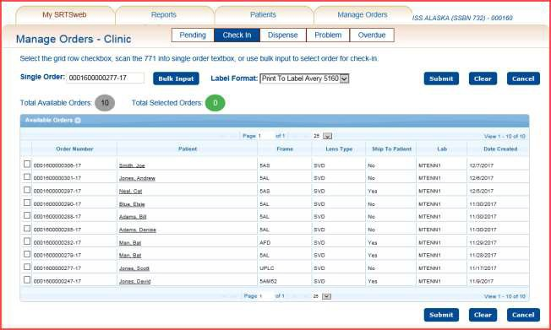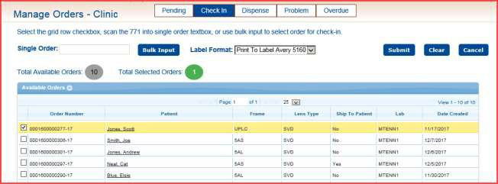

## Quick Search

The user has the option of using the “**Quick Search**” when wanting to check in a single order. Put the order number in the Quick Search and press Go. The option will show to **View Order** or **Check In** depending on the status.



The **View Order** option gives the user the ability to review the order to **Save As New** or

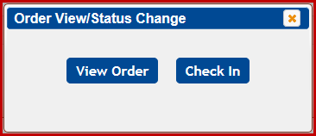

### Reprint 771.

The Check In option gives the user the ability to check in the order.

The order status will change to **Received by Clinic** and the order is now available to be dispensed to the patient.

The Check In option also gives the user the ability to **check in orders that the Lab has not dispensed.** These order numbers are not in the check in grid but the user has the glasses in their possession. The user can type in a single order, type in the Bulk Order Input or scan the DD 771 doing a bulk input.

After typing in the order number press **Enter**. This will give you the message **“Order Number not in Grid”**.

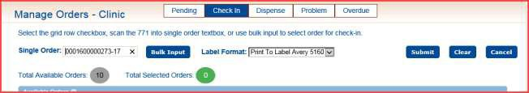

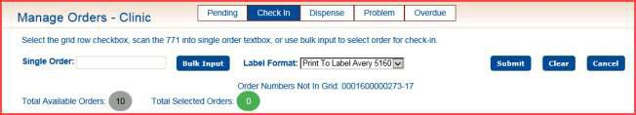

Press **Submit**.

Orders have been checked in and ready to be dispensed.

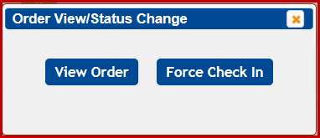

The order status will change to **Clinic Check in – No Lab Checkout** and the order is now available to be dispensed to the patient.

If the user types the order number in the **Quick Search that the Lab has not dispensed**

and pressed **Go** the View Order or Forced Check In tabs will appear.

The **View Order** option gives the user the ability to review the order to **Save As New** or

**Reprint 771**. The **Force Check In** option gives the user the ability to check in the order. The order will then go into the Dispense file.

If the user types the order number in the Single Order box that does not belong to your clinic a message will alert the user.

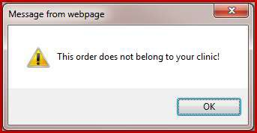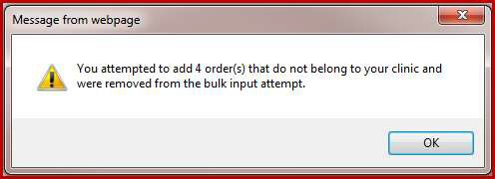

If the user types or scans order number in the Bulk Input box that does not belong to your clinic a message will alert the user.

## Dispense

When selected, this process will display a list of all orders that have been completed through the production process. These orders have been dispensed from the lab and shipped back to the clinic. When an order has arrives at the clinic and been checked in, the order must be dispensed to indicate the clinic has dispensed the order to the patient.

Once an order has been dispensed, the Total Available Check-In count displayed at the top of the screen is recalculated and the updated count is displayed.

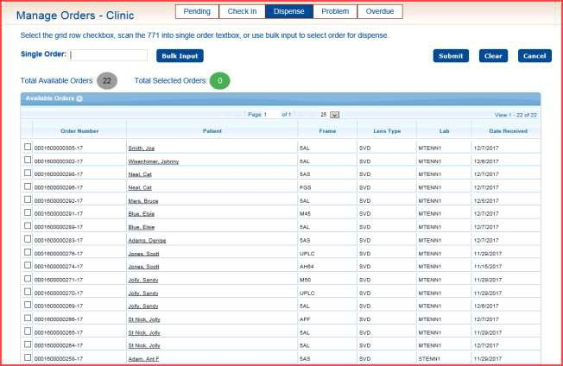

For those orders that will be delivered to the patient at the clinic, the user should print a **Clinic Dispense Report** which provides a delivery confirmation report containing a signature line to be signed when the order is delivered to the patient. This report **MUST** be printed prior to processing in **Dispense Orders** and may be accessed from the **Manage Report** module located in the **Reports** tab.

**NOTE: Orders must be checked in and dispensed. This will enable G-Eyes orders to display glasses to be reordered correctly.**

To print the report go to **Reports – Manage Reports** – select from dropdown **Clinic Dispense Report**. Select Date Range, select Status and Priority or check Null boxes. Press View Report.

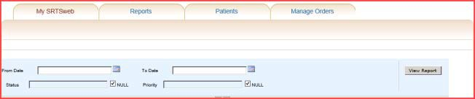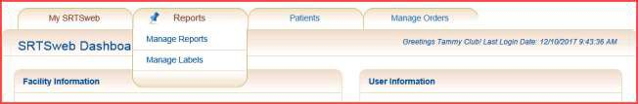

Select method of printing or saving from Export Drop Down Menu.

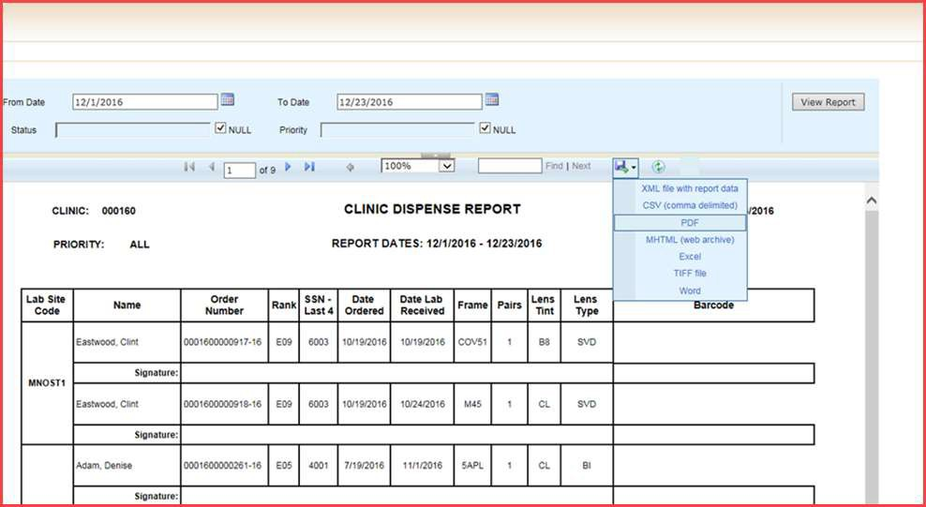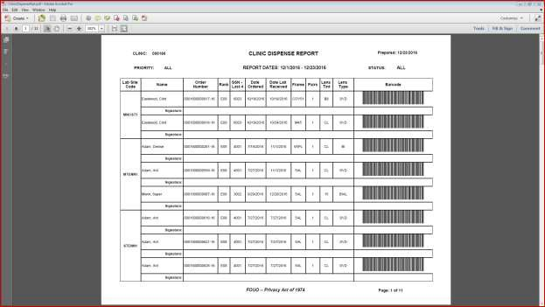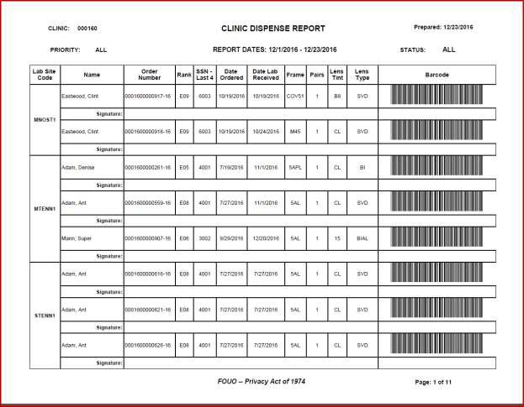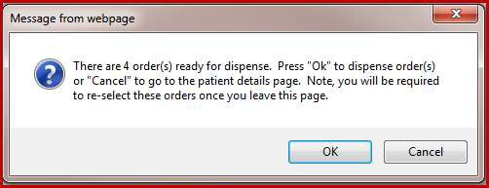

The user has the capability to click on a patient name and be taken to the patient’s information page to research patient or order information. If orders are checked a message will allow you to check in or go to patient detail page.

The user has the capability to sort the grid-views within Dispense. Click on the column to sort. An arrow will show ascending or descending order.

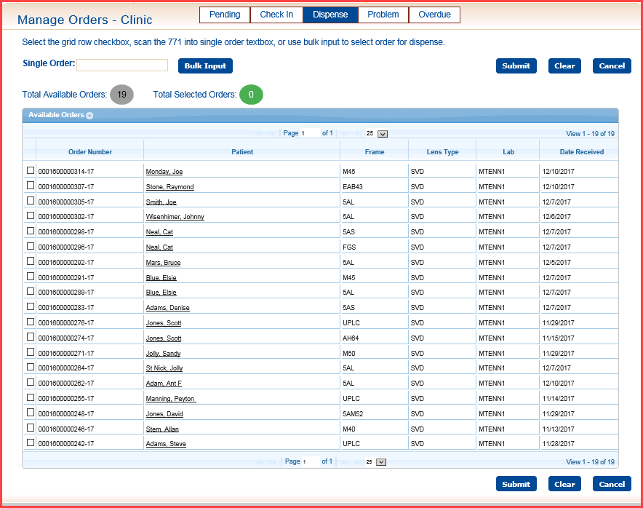

There are 4 methods to dispense these received orders:

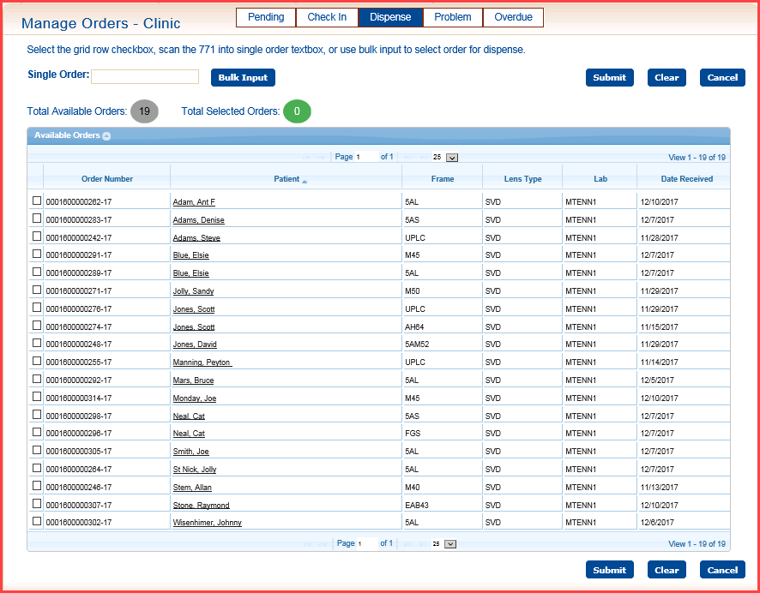

* the user may type an order number into the single order field
* the user may scan the bar code on the order documentation or Dispense Report which represents the order number after pressing Bulk Input
* the user may locate the order in the list of active orders and checking box
* the user may type order number into **Quick Search** and press Go or Enter

## Single Order

To dispense a single order type in the order number in the box and press enter. The order will go the top of the list and be highlighted in yellow. The user can use the single order number as many times as needed.

The **Total Available Orders** show all orders ready for Dispense.

The Total **Selected Orders** will count the number of orders selected to dispense.

**NOTE:** If the columns are rearranged in any other format the orders will not be pulled to the top of the list.

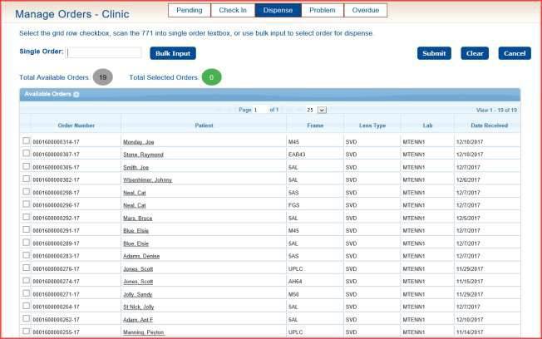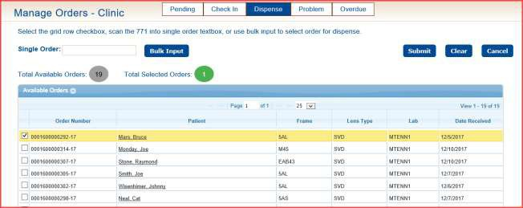

Press **Submit.**

## Bulk Input

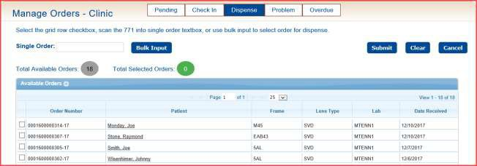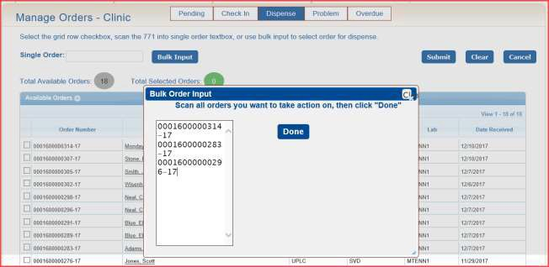

Once the dispense records are displayed, the user may click on the check box labeled **Bulk Input.** The Bulk Order Input box appears. The order number will appear after you scan the order. After scanning the check in box will be checked. Click **Done** when finished and then **Submit** to dispense the orders.

Once the data entry has been completed, click on the **Submit** button to process the order(s). The order status will change to Clinic Dispensed Order or Clinic Dispensed Order “FORCED”.

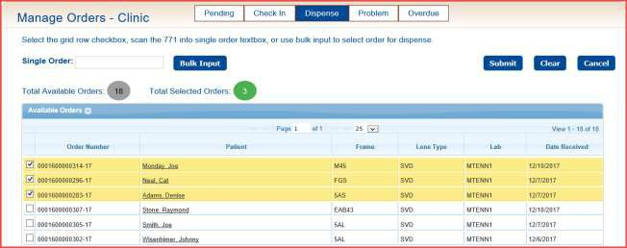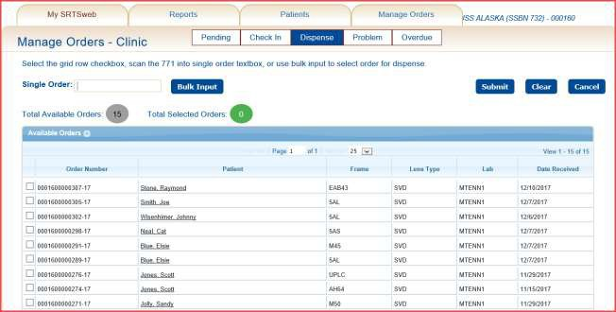

Once an order has been dispensed, the **Total Available Orders** counts and update the screen display with the new number of orders available for dispense.

## Locate Order

The user has the option to find an order number in the grid and checking the box. The order will be moved to the top of the list and highlighted. Press Submit to dispense.

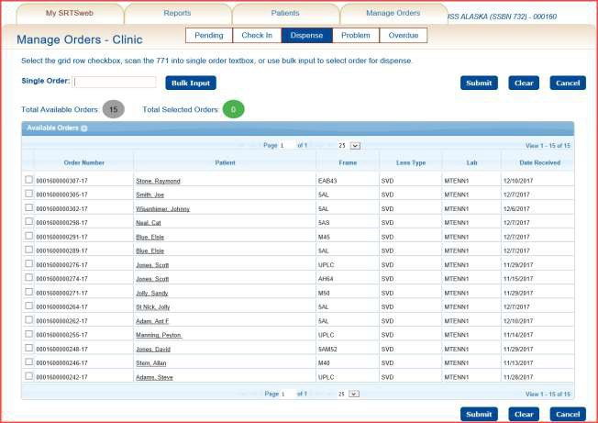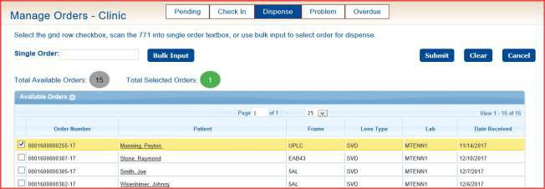

Press **Submit.**

## Quick Search

The user has the option of using the “**Quick Search**” when wanting to dispense a single order. Put the order number in the Quick Search and press Go. The option will show to **View Order** or **Dispense** depending on the status.

The **View Order** option gives the user the ability to review the order to **Save As New** or

### Reprint 771.

The **Dispense** option gives the user the ability to dispense the order.

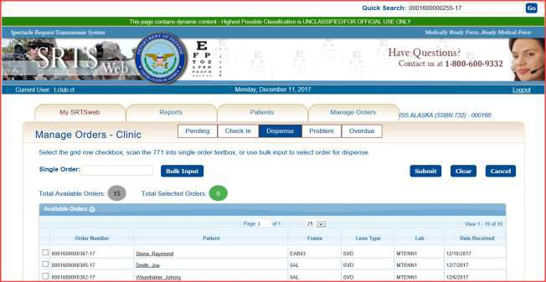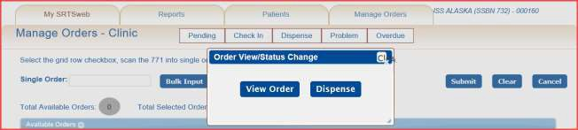

The order status will change to **Dispensed by Clinic.**

## Problems

When selected, this process will display a list of orders with problems that require special handling.

Clinic Orders Problems can include:

* **Lab Rejected** - the clinic has the option to resubmit with status of Clinic Resubmitted Order, Delete order or reprint DD-771.
* **Incomplete orders** - can be updated and submitted by the clinic or deleted.
* **Hold for Stock** – the clinic has the option to check in if received without lab dispensing.

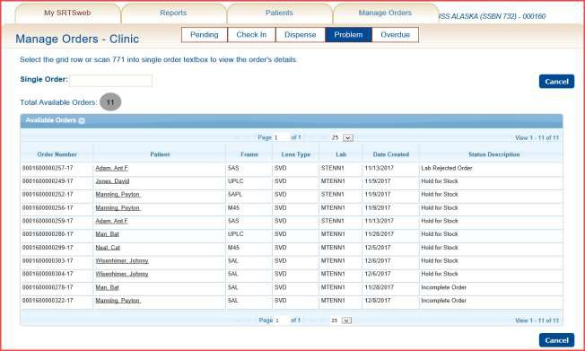

Once an order has been opened and resolved, the Total Available Orders count displayed above the problem list is recalculated and the updated count is displayed.

To update either the Lab Rejected or Incomplete Order, click anywhere on the line of the order except the name.

The user has the capability to click on a patient name and be taken to the patient’s information page to research patient or order information.

The user has the ability to open the **Incomplete Order** and **Update** or **Delete**. The user can view status by hovering over the Order Number.

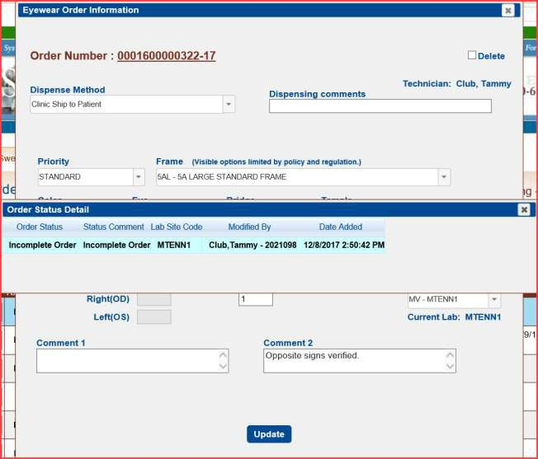

The user has the ability to open by selecting Order History to view new order status.

The user has the ability to open the **Rejected Order** by clicking on the order to Update, add Clinic Justification, or Save as New or Delete.

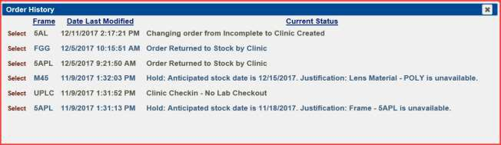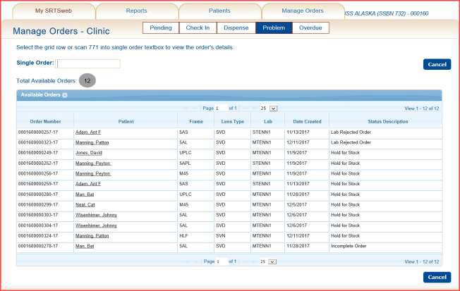

The user needs to delete the rejected order if no action is taking place.

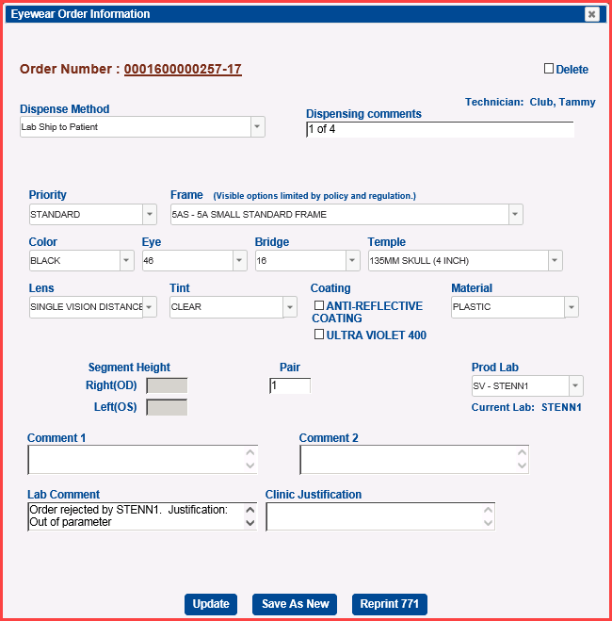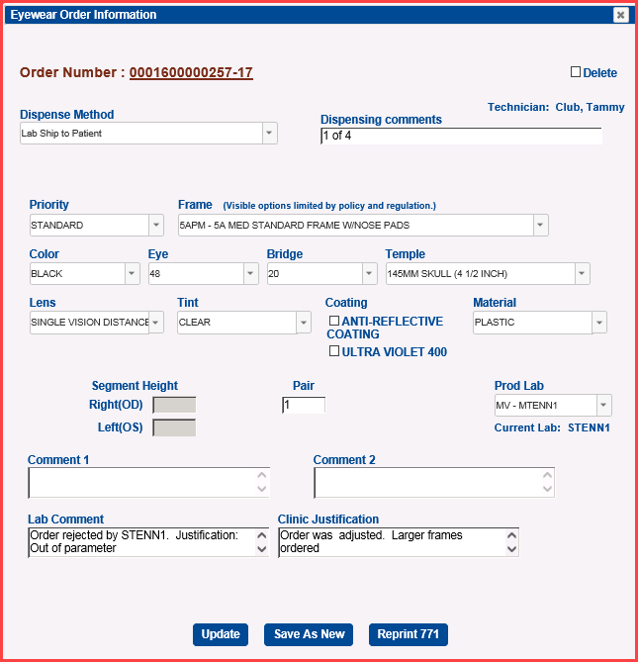

New status shows after typing in Clinic Justification and pressing **Update**.

The user can view status by hovering over the Order Number after selecting from Order History.

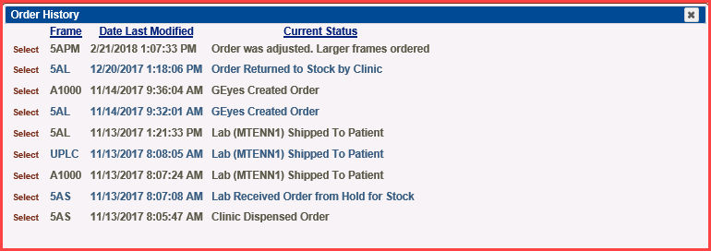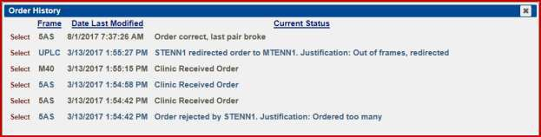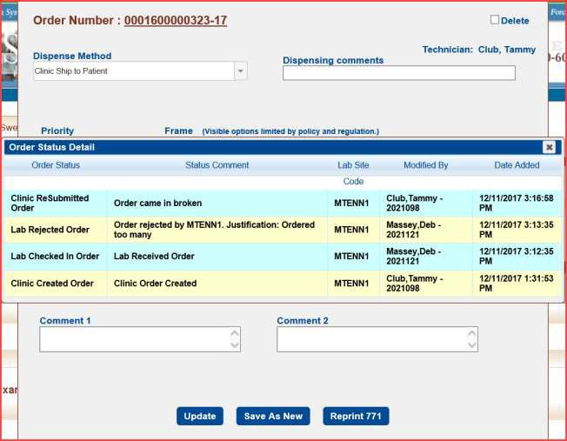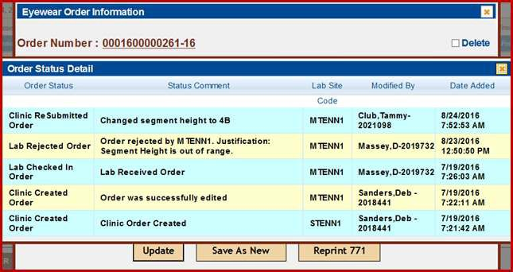

## Overdue

Orders that are at the lab and aged over 10 days go to the Manage Orders – Clinic Order Management – Overdue. Check with the lab to follow up on these orders.

The Total Available Orders count displayed above the Overdue list is recalculated and the updated count is displayed when the order is dispensed by Lab or checked in by clinic.

The user has the ability to check in these overdue orders if they have received the eyewear from the lab. This is discussed in the Check In portion of the guide.

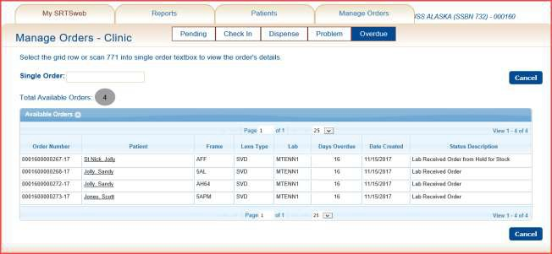

The user has the capability to click on a patient name and be taken to the patient’s information page to research patient or order information.

The user has the ability to open the **Overdue** order by clicking on the line.

User has the ability to print, save or email an Overdue Orders Report from Reports - Manage Reports after opening the report.

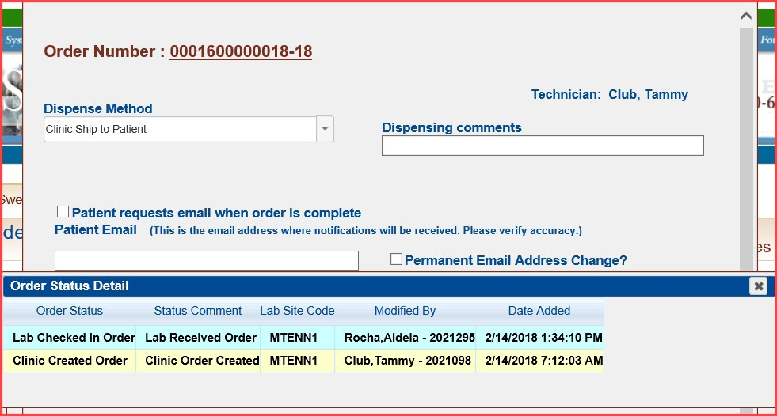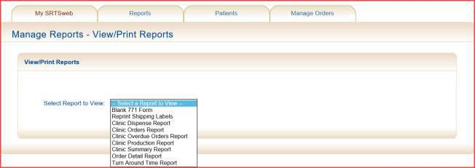

### NOTE: The user needs to contact the lab on Overdue orders.

**Report Samples**

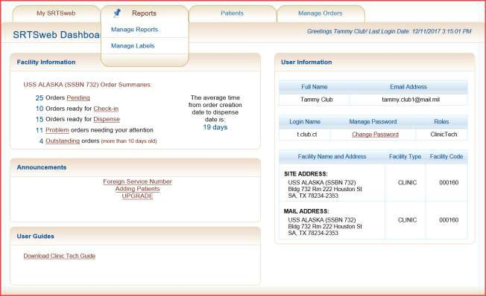

**Blank 771 Form**

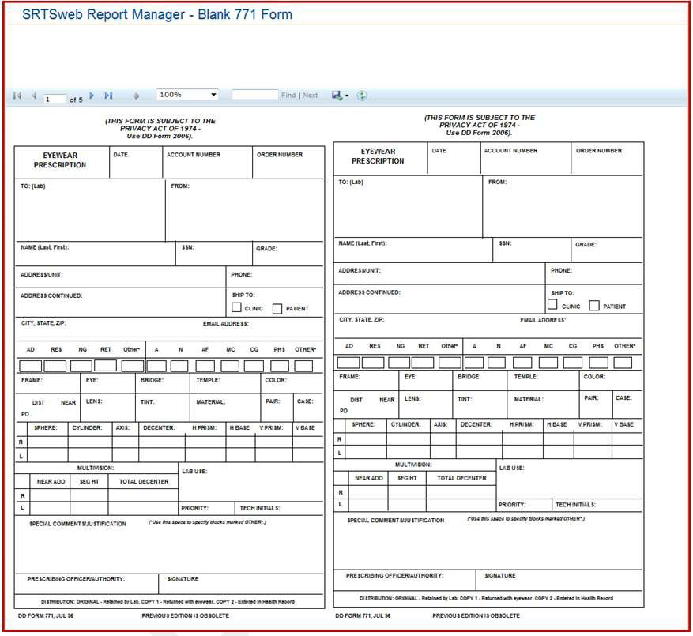

**Reprint Shipping Labels**

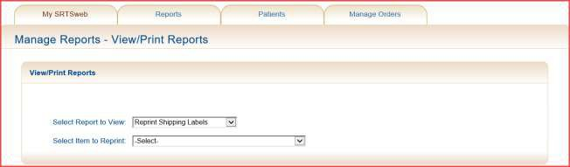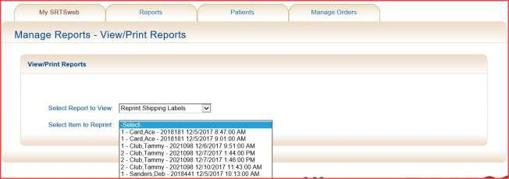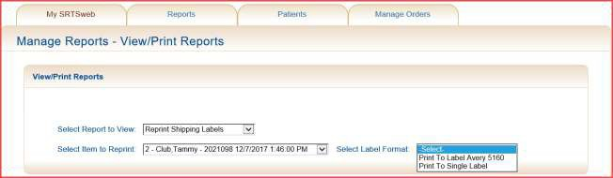

**Clinic Dispense Report**

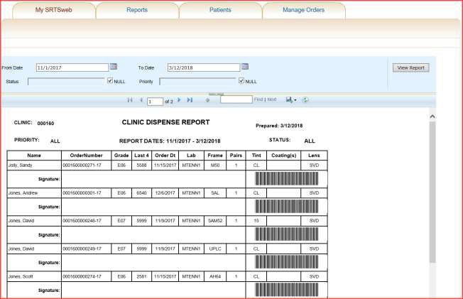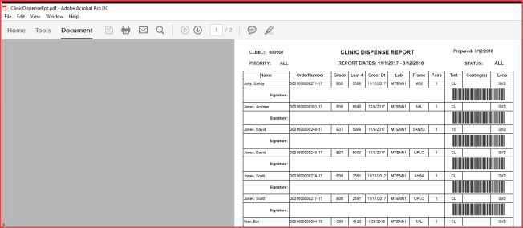

**Clinic Orders Report**

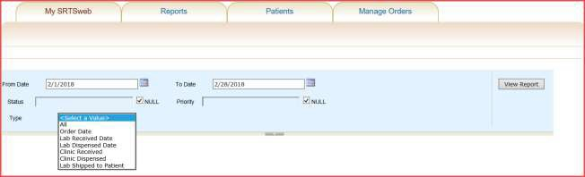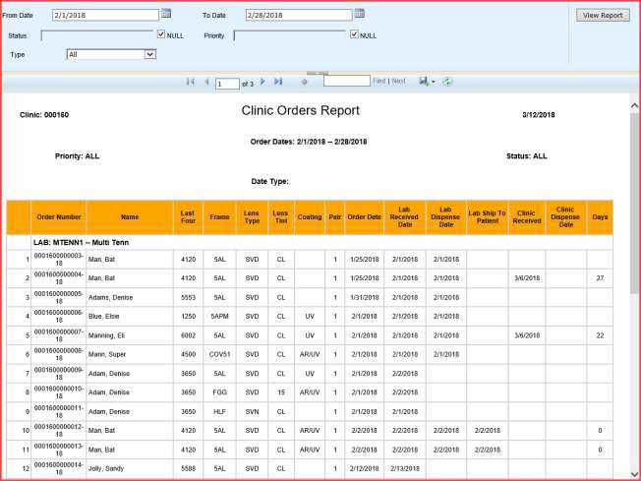

**Clinic Orders Report – All**

**Clinic Orders Report – Ordered Date**

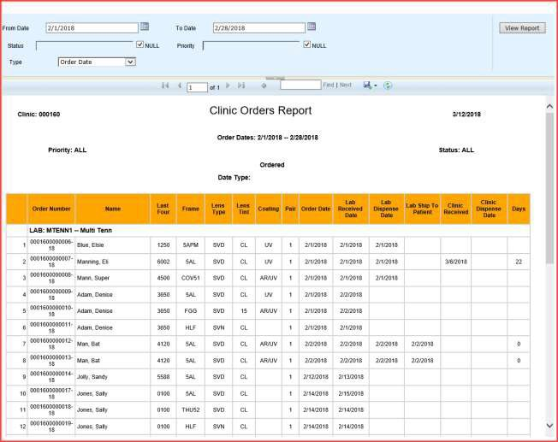

**Clinic Orders Report – Lab Received Date**

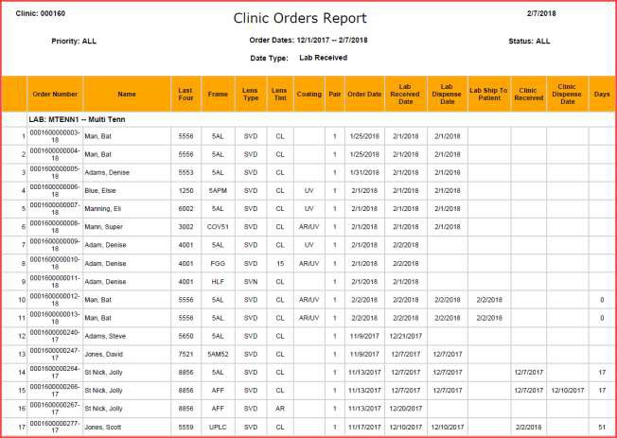

**Clinic Orders Report – Lab Dispensed Date**

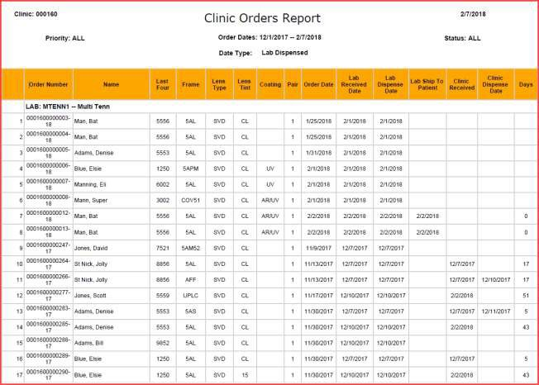

**Clinic Orders Report – Clinic Received**

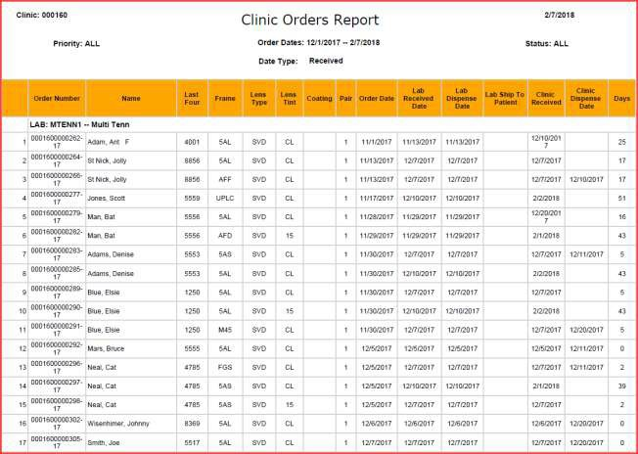

### Clinic Orders Report - Clinic Dispensed

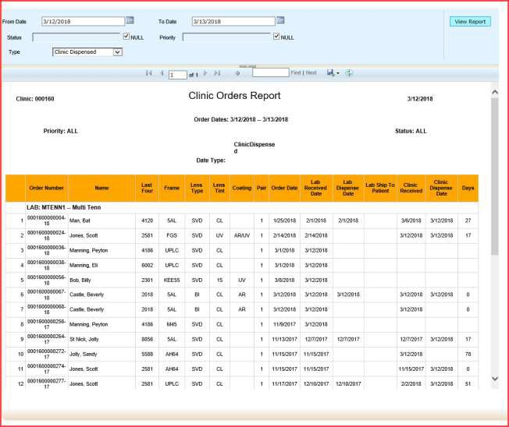

**Clinic Orders Report – Lab Ship to Patient**

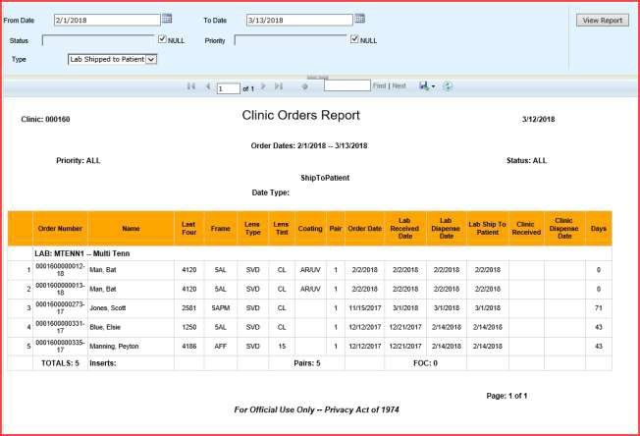

**Clinic Overdue Orders Report**

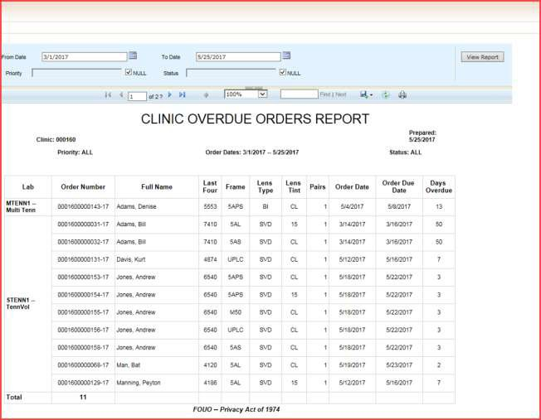

**Clinic Production Report**

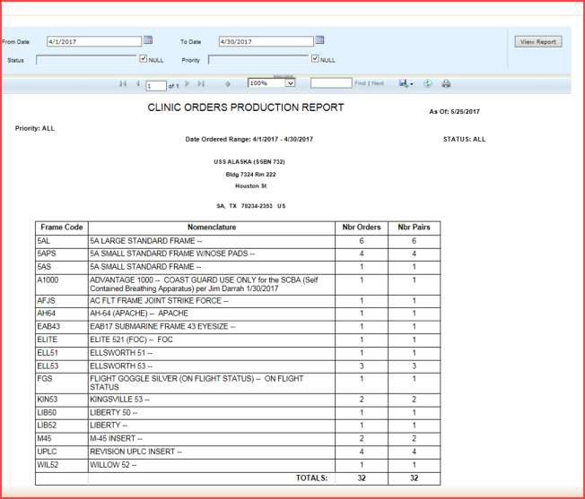

**Clinic Summary Report**

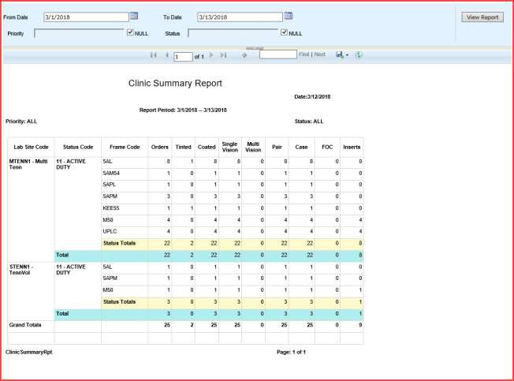

**Order Detail Report**

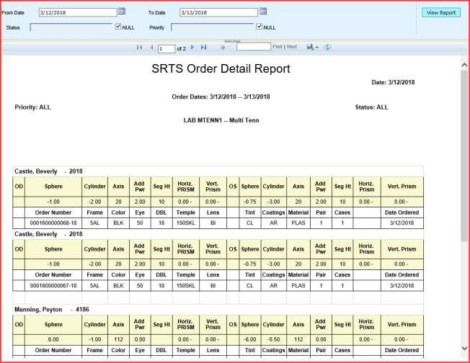

**Turn Around Time Report**

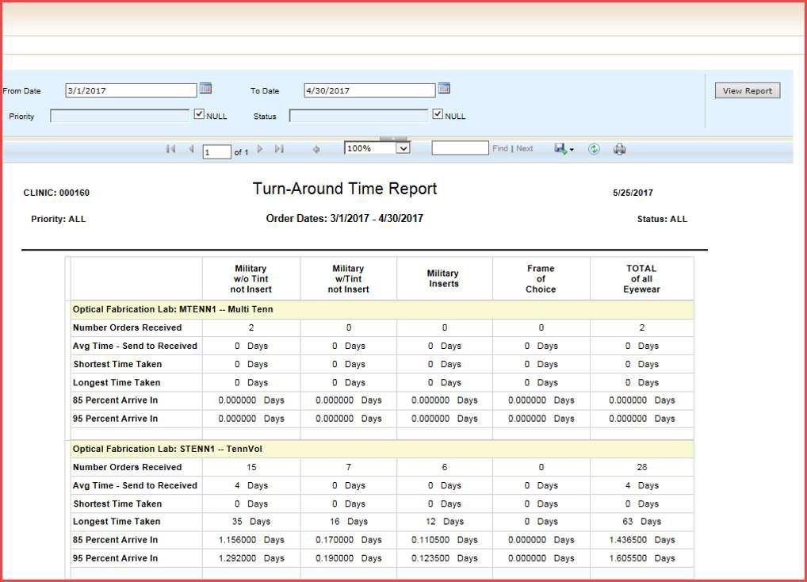

**Manage Labels**

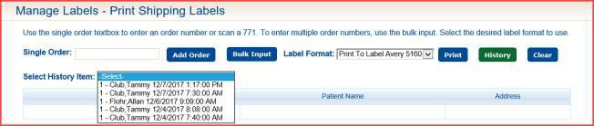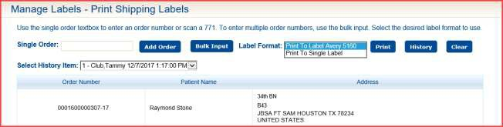

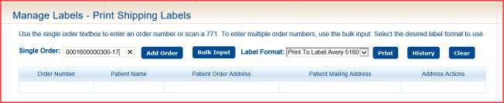

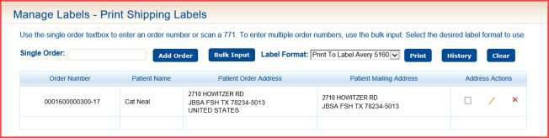

**NOTE: If the address is edited the validation will have to be redone.**